**Universal Published Paper Review**

Introduction

The Quinn Fluid Flow Model (QFFM) is a totally new and novel theory of fluid dynamics in closed conduits. The underlying intellectual property is owned by The Wrangler Group LLC (TWG). It has been developed from first principles and applies to fluid flow in both packed and empty conduits across the entire fluid flow regime including laminar, transitional and turbulent. The model has been validated by applying it to classic studies in both categories of flow embodiments and, in each case, to studies in all fluid flow regimes.

The QFFM can be expressed in two formats. The first format is a dimensional manifestation in which the measured differential pressure across the ends of a conduit is compared to the measured resultant flow rate of the fluid according to the relationships dictated by the model among the many independent and dependent variables pertaining to the physical fluid flow embodiment and pertaining to the fluid itself. The second format is a dimensionless manifestation, which we call Quinn’s Law, where all the individual respective contributions to the pressure drop/fluid flow relationship have been normalized between the model’s two entities, which we call the “Quinn reduced pressure” and the “fluid current” and which we denote with the symbols PQ and Qc, respectively.

Any given combination of the underlying variables prescribed by the QFFM will have a unique pressure drop at any given flow rate. Accordingly, the QFFM is capable of distinguishing between *valid* and *invalid* data. In particular, the QFFM can identify a mismatch between a practitioner’s statement of the values he/she claims to have measured or calculated for the QFFM variables and the practitioner’s measured flow rate and pressure drop. We consider any mismatch to be an *invalid* empirical result. It follows that for every *invalid* empirical result there is but one *valid* corrected result.

Before one can apply Quinn’s Law to any given empirical result that result has to be validated using the dimensional manifestation of the QFFM. This, in turn, is because one cannot normalize properly for all the individual respective contributions unless all the variables are correctly identified and their values are commensurate with the measured pressure drops and fluid flow rates. In general, we can state that since most of the underlying variables pertaining to a fluid flow embodiment are relatively easy to measure, the correction usually pertains to the more difficult-to-measure variables. In the case of a packed conduit, the problematical measurements include particle sphericity, average particle diameter and conduit external porosity, In the case of an empty conduit, the weak link in terms of measurability is the conduit’s inner wall roughness.

QFFM is a unique and powerful new tool in the arsenal of the fluid flow practitioner. In particular, when experiments are conducted in the transitional and/or turbulent regimes, the conventional methodology does not provide any reliable way to verify the accuracy of the results across a broad spectrum of Reynolds numbers. Thus, it is in these regions of the fluid flow regime that the QFFM will be shown to be most useful. In fact, it is a direct consequence from the statements contained herein that one needs only to measure pressure drop and fluid flow rate to evaluate the quality of one’s experimental technique. This new development in fluid dynamics means that those of us who have spent our entire lives doing fluid flow measurements can now enjoy the same benefits as our counterparts within the field of electricity and magnetism.

Paper Summary

We review here a published article in ***Advanced Powder Technology (2016)*,** entitled **Determination of pressure drop for air flow through sintered metal porous media using a modified Ergun equation*,*** by **Zhong et al**. For easy reference to the reader, we print here in its entirety the abstract in the paper.

**Paper Abstract**

Sintered metal porous media currently play a significant role in a broad range of industrial equipments. The flow properties in porous media are generally approximated by Forcheimer regime or Ergun regime. In this study, a modified Ergun equation is developed to correlate the pressure drop with flow rate. Experimental and theoretical investigations on pressure drop are conducted with a series of metal-sintered porous media. A viscous drag region and a form drag region are defined with Reynolds number Re = 1 and Re = 10 as the boundary. The coefficient  and  in the equation are determined by,  first in the viscous drag region, then  in the form drag region. It is confirmed that theoretical pressure drop versus flow rate in terms of the modified Ergun equation provides close approximations to the experimental data. In addition, it is found that compressibility effect can aggravate the pressure drop. It is also concluded that there exists a range of transitional diameters, within which the wall effect on the pressure drop would become extraordinarily uncertain.

**Data Analysis**

TWG has performed an extensive evaluation of the above referenced published article utilizing the QFFM. We commence our evaluation of the paper with an in-depth analysis of the reported data.

In order to evaluate the conclusions expressed in the paper concerning the value of the constants in the modified Ergun equation which are purported to be a representative model of the measured data, we compared their measured data for the Group 2 data set to the general model of the Ergun equation using the constants asserted in the paper. Fig. A herein is a replica of Fig. 5 in the paper, showing our calculated pressure drops versus mass flow rate for the 9 different in line filters used in the Group 2 data set. A comparison of these two plots establishes that we have correctly captured the measured data in our calculated values and since these values are the result of applying our fluid flow model, it establishes that we have successfully identified all the correct underlying packed conduit parameters as well as their values which correlate the measured values of pressure drop and flow rate..

**Fig. A**

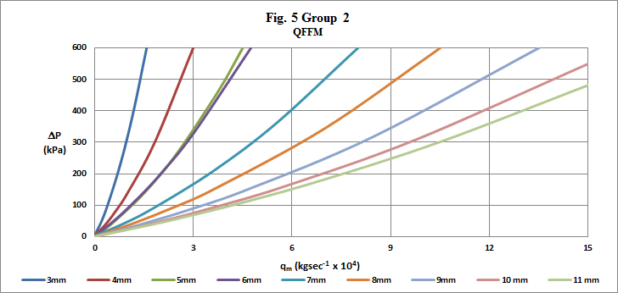

Fig. B, on the other hand, is a plot using the Modified Ergun equation prepared by TWG which contains the constants asserted in the paper of 550.7 and 14.5 for the values of  and , respectively, and our back-calculated values for the underlying packed conduit parameters specified in the general form of the Ergun equation. A comparison of Fig. B herein and Fig.5 in the paper clearly demonstrates that their conclusion regarding the modified Ergun equation constants does not accurately represent their measured data. In fact, it overstates the measured pressure drop by about a factor of 4.

**Fig. B**

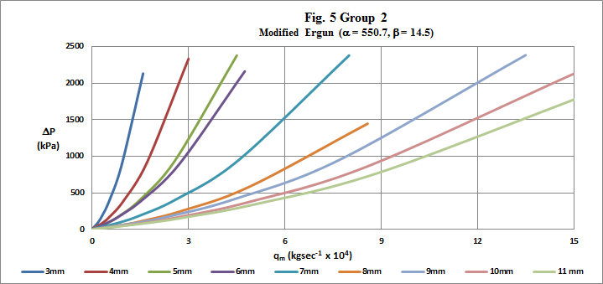

Our Fig. C herein is a replica of Fig. 6 in the paper showing that our calculated values using QFFM correlate perfectly with the author’s measured values for the low pressure drop measurements.

**Fig. C**

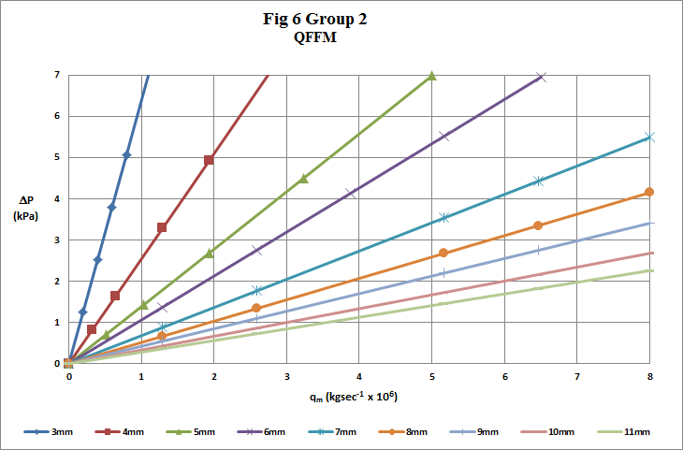

In our Fig. D, we show a replica of Fig. 12 in the paper. Our plot does not correspond to the author’s plot in the paper and it directly flies in the face of the author’s assertion concerning the effect of fluid compressibility in the pressure flow relationship. As our plot demonstrates, higher pressure *is* generated with a compressible fluid for a given flow rate but there is a corresponding increase in the Reynolds number due to the higher values for fluid density and thus, on an apples to apples comparison basis, the author’s comment that “ the dashed line for the incompressible case, exhibits a less conspicuous pressure drop, indicating that compressibility effect can aggravate the pressure drop” does not fit reality over a broad range of modified Reynolds number values.

**Fig. D**

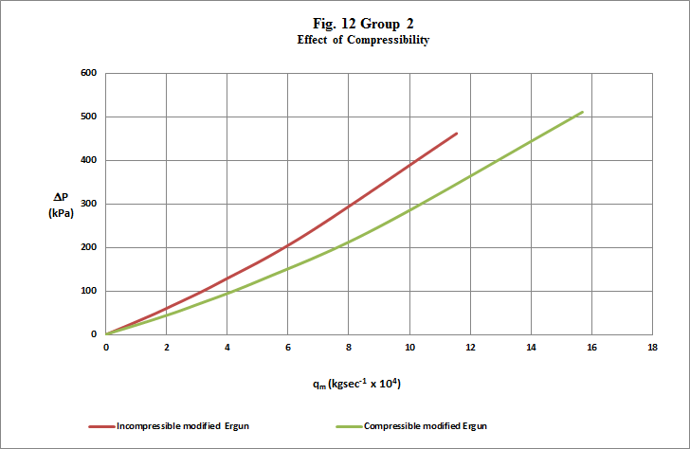

**Discrepancy Explained**

The explanation underlying this apparent contradiction between our analysis and the authors conclusions expressed in the paper arises from the fact that the authors in their paper did not separately identify the necessary parameters in the general form of the Ergun equation and accordingly, they came to an incorrect conclusion regarding the constants in that model which represents their measured data. For instance, they did not identify the spherical particle diameter equivalent corresponding to their irregularly shaped particles. In addition, although their experimental concept was well thought out by taking flow rate and pressure drop measurements at very low pressure when the density of the compressible fluid was known, i.e. its’ value at STP, and, in addition, taking flow rate and pressure drop measurements under higher pressure when the fluid was compressed, their experimental protocol was flawed because it did not permit them to identify the corresponding changing fluid density at the higher pressures. They would have had to have used both these entities, i.e. the spherical particle diameter equivalent as well as the fluid densities at all values of their fluid velocities in their model for the modified Ergun equation, in order to arrive at the correct conclusion regarding the constants in that equation which best represents their measured data. In addition,the authors of this paper have taken liberties with the Ergun equation which are not permitted by the Laws of Nature. Their version of the Ergun equation expressed in their equation (6) dictates the use of the spherical particle diameter equivalent as the product of the particle sphericity  and the measured particle diameter DP. In addition, the value of the parameter  , also in their equation (6) representing the fluid density must be that value corresponding to the actual fluid density within the packed bed when the pressure drop measurements were recorded. The authors did not follow this teaching in their application of the modified Ergun equation to their measured data. Accordingly, their conclusions as to the value of the equation constants are based upon flawed data.

**Fig. E**

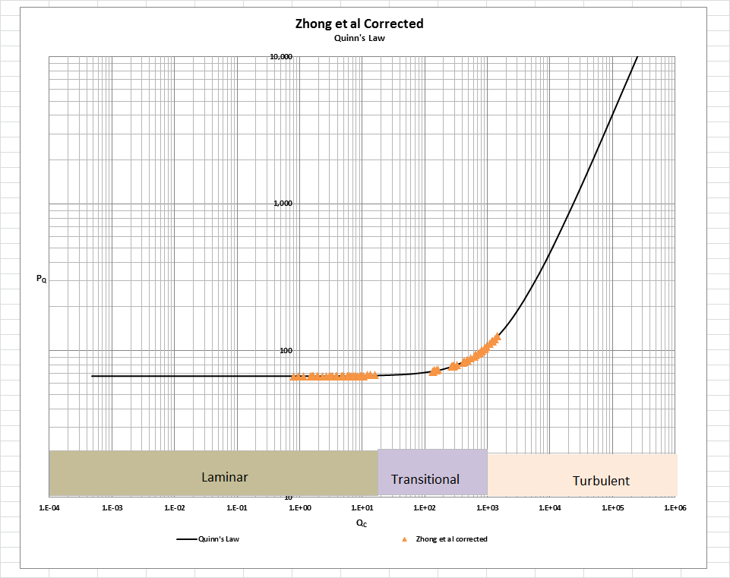

In Fig. E herein, we have provided our validation of the paper’s corrected data by a comparison of the data to Quinn’s Law. This normalized relationship is presented herein in the form of a plot of PQ versus QC, whichis the frame of reference of Quinn’s Law. This frame of reference is a transformation derived from the dimensional fluid flow relationship embedded in the QFFM. The relationship between these two unique reduced Quinn parameters is *linear*. However, we chose to present it as a *log-log plot* herein to provide emphasis at both extremes of the fluid flow regime. This plot is based upon both our own experimental data and *independent accepted classical reference data* which cover flow in both packed and empty conduits, over the entire fluid flow regime. (Note that the three distinct flow regimes of laminar, transitional and turbulent are clearly marked in the log-log plot.) As can be seen, the data reported in this paper, as corrected and as displayed in the form of a plot of PQ versus QC , lines up perfectly with Quinn’s Law

[Note: we do not herein provide the back-up for the validation of the plot of Quinn’s Law depicted in our Fig. B. For a description of the sources, both personal to TWG and from independent accepted classical references, on the basis of which the Quinn’s Law plot was validated, see the general introduction to this Universal Published Paper Review tab.

**Conclusion.**

We conclude that the results in this paper suffer from deficiencies in the experimental protocols used in the experiments. As a result, there is a mismatch between the measured variables and the measured pressure drop. This mismatch is only *apparent and quantifiable* in the context of the QFFM and, therefore, can only be corrected using this model. Accordingly, since the authors did not have access to Quinn’s Law when they wrote the paper, they *could not have* corrected the data before attempting to rationalize it by applying the model of Ergun. This inherent tendency to *modify* existing equations to correlate *unsubstantiated* empirical measurements has long since contributed to the confusion that exists in this field of study and has had a tendency to create the *false illusion* that these so-called conventional equations are of some *value* when, in reality, they are nothing more than *invalid* relationships.

Moreover, even if the authors applied the classical unmodified equation of Ergun, for instance, or their own newly-minted modified Ergun equation, they could not have generated *the* match inherent in the Laws of Nature between the calculated pressure drops of their chosen equation and their own measured pressure drops – unless, of course, they had serendipitously, or otherwise, identified the same *unique* equation as that embedded in the QFFM.

Finally, although a detailed evaluation of the experiments reported in the paper under review, including an identification and quantification of the specific variables in each fluid flow embodiment which we claim the QFFM prescribes need to be corrected, is clearly within the capability of TWG, concerns about maintaining the confidentiality of the QFFM and Quinn’s Law – which, at this time, are still proprietary - dictate that such a development is premature.