**Universal Published Paper Review**

Introduction

The Quinn Fluid Flow Model (QFFM) is a totally new and novel theory of fluid dynamics in closed conduits. The underlying intellectual property is owned by The Wrangler Group LLC (TWG). It has been developed from first principles and applies to fluid flow in both packed and empty conduits across the entire fluid flow regime including laminar, transitional and turbulent. The model has been validated by applying it to classic studies in both categories of flow embodiments and, in each case, to studies in all fluid flow regimes.

The QFFM can be expressed in two formats. The first format is a *dimensional* manifestation in which the measured differential pressure across the ends of a conduit is compared to the measured resultant flow rate of the fluid according to the relationships dictated by the model among the many independent and dependent variables pertaining to the physical fluid flow embodiment and pertaining to the fluid itself. The second format is a *dimensionless* manifestation, which we call Quinn’s Law of Hydrodynamic Continuity, where all the individual respective contributions to the pressure drop/fluid flow relationship have been normalized between the model’s two entities, which we call the “Normalized pressure” and the “fluid current” and which we denote with the symbols PQ and CQ, respectively.

Any given combination of the underlying variables prescribed by the QFFM will have a unique pressure drop at any given flow rate, *all as dictated by the Conservation Laws of Nature.* Accordingly, the QFFM is capable of distinguishing between *valid* and *invalid* data. In particular, the QFFM can identify a mismatch between a practitioner’s statement of the values he/she claims to have measured or calculated for the QFFM variables and the practitioner’s measured flow rate and pressure drop. We consider any mismatch to be an *invalid* empirical result. It follows that for every *invalid* empirical result there is but one *valid* corrected result.

Before one can apply Quinn’s Law to any given empirical result that result has to be validated using the dimensional manifestation of the QFFM. This simply means that the left hand side of the pressure gradient versus flow rate equation must be correctly balanced on the right hand side of the equality sign by all the individual variables which constitute the relationship. This, in turn, is because one cannot normalize properly for all the individual respective contributions unless all the variables are correctly identified and their values are demonstrably commensurate with the measured pressure drops and fluid flow rates. The discrete values of the many conduit/fluid variables underlying any measured data set of pressure gradient and flow rate are dictated by the Conservation Laws of Nature which are generally referred to as Laws of Continuity when the principle of conservation is applied in the context of a moving entity, in this case, the fluid flowing through the conduit. Accordingly, a differentiating element of the QFFM from all other popular models is its built-in capability to insure that continuity is always preserved in any reported experiment. This distinguishing feature of the QFFM will almost invariably generate a conflict with other empirical models which do not recognize the principle of continuity because a practitioner’s ability to measure accurately and precisely the underlying variables is almost always trumped by the *inherent precision* of continuity. In general, we can state that since most of the underlying variables pertaining to a fluid flow embodiment are relatively easy to measure, the correction for continuity usually pertains to the more difficult-to-measure variables which are typically, average particle *diameter*, particle *sphericity*, and conduit *external porosity*. On the other hand, inner wall *roughness* is also difficult to measure, but its impact is on pressure drop reconciliation, which is on the opposite side of the ledger to continuity, in the pressure flow relationship.

Consequently, the QFFM is a unique and powerful new tool in the arsenal of the fluid flow practitioner. In particular, when experiments are conducted in the transitional and/or turbulent regimes, the conventional methodology does not provide any reliable way to verify the accuracy of the results across a broad spectrum of Reynolds numbers. Thus, it is in these regions of the fluid flow regime that the QFFM will be shown to be most useful. In fact, it is a direct consequence from the statements contained herein that one needs only to measure pressure drop and fluid flow rate to evaluate the quality of one’s experimental technique. This new development in fluid dynamics means that those of us who have spent our entire lives doing fluid flow measurements can now enjoy the same benefits as our counterparts within the field of electricity and magnetism.

REVISION 1

QFFM Continuity Ranking Index Comparison

Beginning in January, 2018, we are adding a new feature to our Universal Published Paper Reviews. In order to provide a frame of reference familiar to the practitioner, we will include in our reviews a direct comparison of our analysis of an author’s results under the QFFM with an analysis under one or more conventional models. For example, when the fluid regime is confined to laminar flow, we will utilize Poiseuille’s accepted model for flow in empty conduits to provide a calibration against the QFFM in the empty conduit counterpart of the packed conduit under study. Likewise, when the fluid regime is other than laminar, we will utilize a quadratic representation of the pressure flow relationship in the mode taught originally by Reynolds and more recently by Forscheimer to accommodate kinetic contributions. Finally, if appropriate, we may provide a comparison of an analysis under the QFFM with an analysis under a Q modified Ergun type model.

In addition, in order to inform the reader as to the relative merit of the experimental protocol used in a particular experiment, we will rank each experiment based upon a comparison of the measured result to that predicted by the QFFM using a quadratic frame of reference. We will accomplish this calculation by evaluating the reported pressure drop as an absolute percentage at each reported flow rate (average) of what the QFFM predicts. For instance, as shown in the Table below, if the reported pressure drop had an average discrepancy of 2 % (absolute) based upon the average calculated discrepancy at each flow rate reported, the experiment would be assigned a rank of A+; similarly, if the reported pressure drop had an average discrepancy of 20% based upon the average calculated discrepancy at each flow rate reported, the experiment would be assigned a rank of B. We will assign a ranking to each experiment based upon the following hierarchy of results and report the results in a comparison Table on this web site for easy reference by a practitioner.

QFFM Ranking System

|  |  |  |
| --- | --- | --- |
| Rank | % Discrepancy | Description |
| A+ | 0-5 % | Excellent |
| A | 5-10 % | Very Good |
| B+ | 10-15 % | Good |
| B | 15-20 % | Fair |
| C+ | 20-25 % | Poor |
| C | 25-30 % | Inadequate |
| D | 30-35% | Unacceptable |
| F | > 35 % | Fail |

Our Rev-1 is totally consistent with our previous methodology; it is simply designed to corroborate our analysis under the QFFM by giving the practitioner an additional way in which to view the author’s data through the lens of more well understood and accepted models and to provide an index of relative merit for the accuracy and precision of the underlying experimental methodology.

Paper Summary

We review here a published article in **International Journal of Engineering and Technology Volume 2 No. 12, December, 2012**, entitled **Experimental Study of Darcy and Non-Darcy Flow in Porous Media** by **Orodu et al.** For easy reference to the reader, we print here in its entirety the abstract in the paper.

**Paper Abstract**

A simple experimental set-up is used to validate capillary-tube models of flow in porous media for (non-) spherical particles and coarse grains of particular/specific mesh sizes. Of the two models used, one model characterizes the structure of the media apart from particle diameter or equivalent particle diameter for non-spherical objects compared to the other model. The magnitude of computed tortuosity for particles/grains studied is in order, however, that of the spherical particles was slightly higher than published values for spheres. Likewise, the ratio of dynamic to static specific surface area was below anticipated and known results in literature. For the non-spherical particle that was approximated as a half-oblate spheroid, the possible error in computed volume and surface area may be the reason for the deviation of computed equivalent diameter from the effective diameter obtained by fitting Ergun correlation to experimental result. The deviation of computed results based on the conducted experiment may in fact be due to error in appropriately fitting straight line to plotted data and precision error of gauges, and possible hysteresis at low flow velocity due to experimental procedure.

**Data Analysis**

TWG has performed an extensive evaluation of the above referenced published article utilizing the QFFM. We commence our evaluation of the paper with an in-depth analysis of the reported data.

The publication contains 6 experiments each pertaining to different particle morphology and all packed into the same dimensioned conduit. For ease of description we designate them a through f as follows;

1. These are spherical glass spheres (circa 1 mm)
2. These are spheroidal glass oblates (circa 3.255 mm)
3. Irregularly shaped gravel particles with a specific particle size range (circa 4.76 mm)
4. Irregularly shaped gravel particles with a different particle six range (circa 6.3 mm)
5. Irregularly shaped gravel particles with a different particle six range (circa 9.5 mm)
6. Irregularly shaped gravel particles as a composite of mixed particle size fractions
7. **Corroborating the QFFM in Laminar Flow (Fig. A-1)**

In our Fig.A-1 herein we evaluate the packed conduit under study by hypothetically removing all the particles from the column and evaluating the empty conduit using the same fluid as reported in the paper but at very low flow rates. This technique removes all the uncertainty associated with the measurement of particle size, particle shape and packed conduit external porosity, the three variables which are the most challenging from a measurement perspective. Additionally, our analysis compares the calculated pressure gradient generated by the QFFM and the Poiseuille model at values of the flow rate *close to zero*, i.e. laminar flow. We can legitimately do this for *any* experiment because the value of zero flow rate (q = 0) and its corresponding counterpart zero pressure drop (P = 0) represent *the* universal fluid dynamic calibration point which grounds *in reality* all mathematical constructs, be they *dimensional* or *dimensionless*. In this way we can establish for the reader a *demonstrable* calibration of the QFFM against Poiseuille’s equation for the *dimensional* manifestation of the QFFM.

As shown in our Fig. A-1, we use a quadratic frame of reference to compare both flow models plotting the pressure gradient on the y axis and the superficial linear velocity on the x axis. As can be seen from the plot, both models are virtually identical when the calculated flow rate is very close to zero, but the QFFM model has a slight deviation as the flow rate increases. This deviation is caused by *kinetic* contributions as the modified Reynolds number increases. Such contributions are not recognized by Poiseuille’s model since it does not contain a kinetic term, i.e. it only captures *viscous* components of energy dissipation. Accordingly, as shown in the plot, the QFFM is virtually equivalent to the Poiseuille model for flow in this conduit when the fluid flow regime is confined to laminar and, moreover, is structured to capture kinetic contributions should the measured flow rates *reported for this packed conduit* extend beyond the laminar flow regime, something Poiseuille is incapable of accomplishing.

Fig A-1

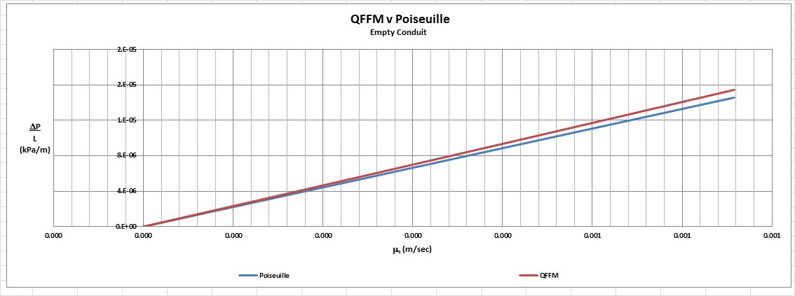

1. **Quantification of the embedded discrepancy in the reported experiment (Fig. A-2).**

In our Fig.A-2 herein, we include the raw data provided in the paper as our baseline and we use our QFFM, again in a quadratic frame of reference, to demonstrate the discrepancy embedded in the reported data for the packed conduit. In addition, we also show the QFFM corrected data by using its inherent architectural design to identify the correct combination of the packed conduit sensitive variables of particle sphericity (p), spherical particle diameter equivalent (dp), channel wall roughness profile

(w), and conduit external porosity (0), underlying the reported values for pressure gradient and fluid flow rate. Finally, in addition to the correlation shown between the reported results and the QFFM corrected results, we include a Q modified Ergun model equivalent with identified viscous and kinetic constants of A and B, respectively.

Fig. A-2

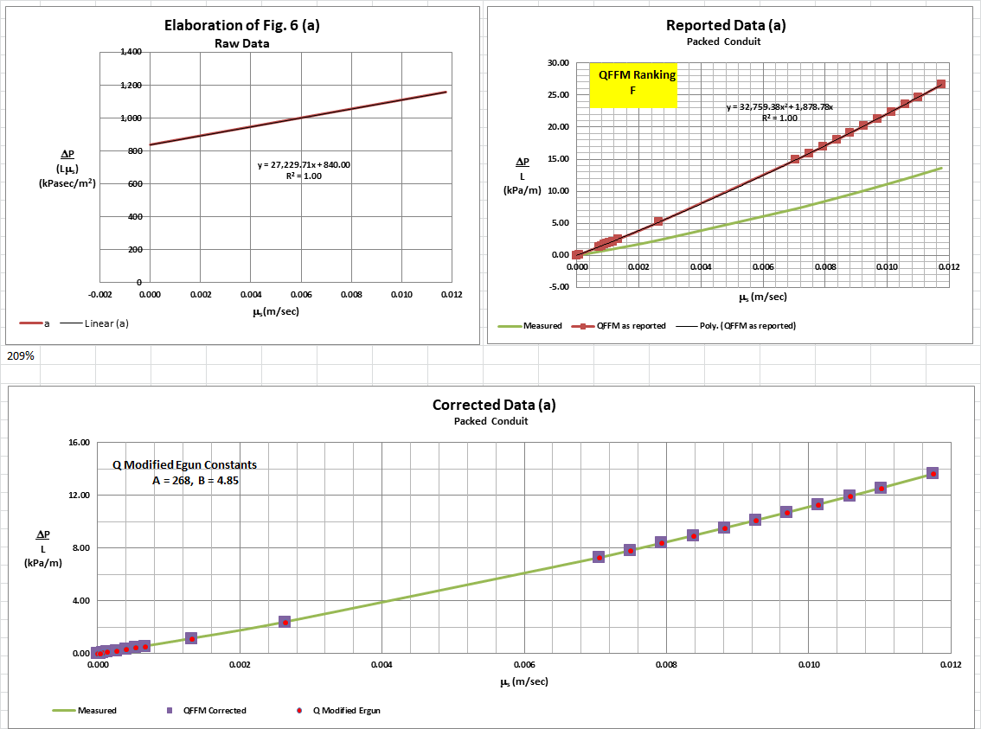

In the case of experiment a, our analysis demonstrates that while the particle shape was relatively close to that of a perfect sphere (p = 0.952), it is 5 % lower than reported. The external porosity was 46.5%, which is 18 % larger than that reported by the authors. Note that the conduit to particle diameter ratio (D/dpm) = 38 was relatively large corresponding to the relatively low coefficient value of 2.1 for w in the QFFM. Finally, although our identified Q modified Ergun constants are 268 and 4.85 for A and B, respectively, there was a relatively low, yet significant, kinetic contribution to energy dissipation in this experiment because the upper flow rate measurements were taken in the transitional region of the fluid flow regime and, in addition, there was also some secondary wall effect.

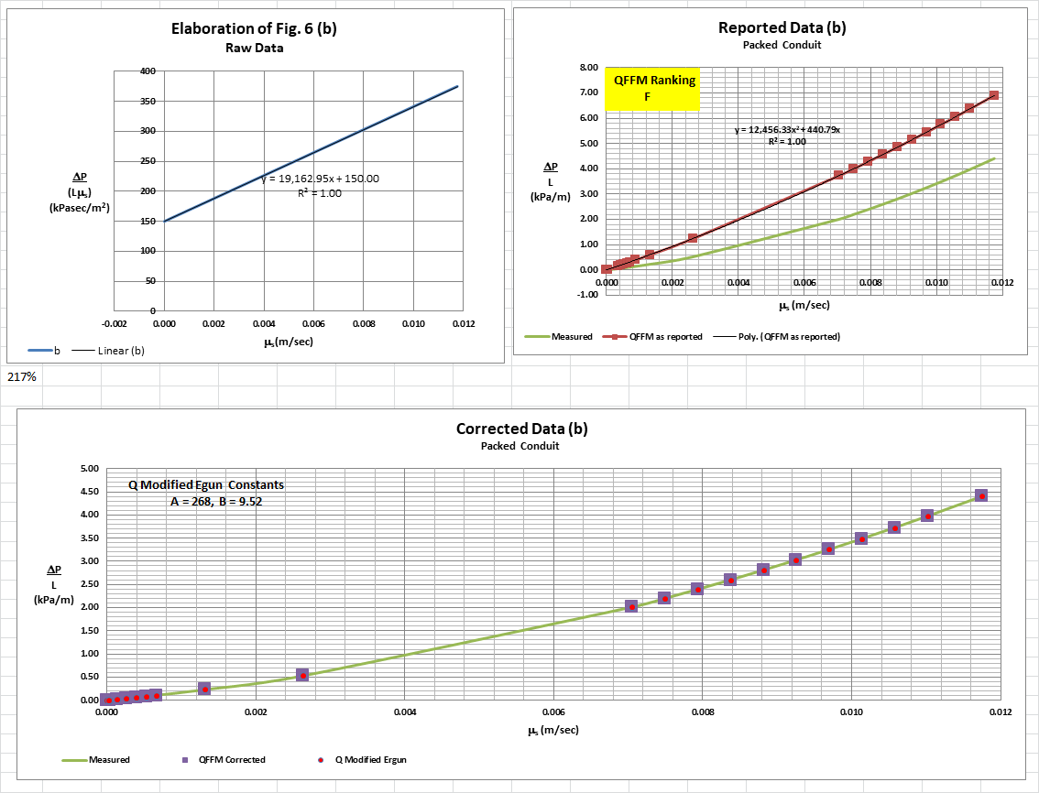

In the case of experiment b, our analysis demonstrates that the particles were moderately irregular (p = 0.525), which is 7 % lower than reported. The external porosity was 52%, which is 23 % larger than that reported by the authors. Note that conduit to particle diameter ratio (D/dpm) = 12 was increasingly lower corresponding to an increasingly higher coefficient value of 7.4 for w in the QFFM. Finally, although our identified Q modified Ergun constants are 268 and 9.52 for A and B, respectively, there was an increasingly higher kinetic contribution to energy dissipation in this experiment because the upper flow rate measurements were taken in the transitional region of the fluid flow regime and, in addition, there was a significant secondary wall effect.

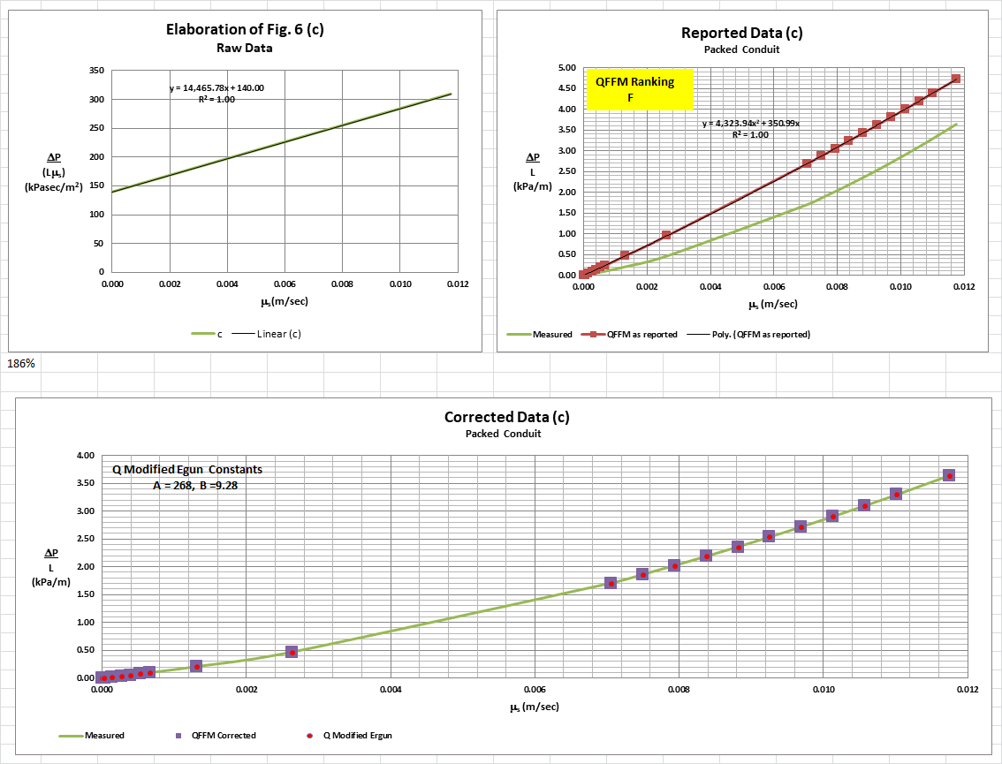

In the case of experiment c, our analysis demonstrates that the particles were increasingly more irregular in shape (p = 0.247), which is 7 % lower than reported, but the external porosity was 60.3%, which is 18 % larger than that reported by the authors. Note that the conduit to particle diameter ratio (D/dpm) = 8 was increasingly lower corresponding to an increasingly higher coefficient value of 11.7 for w in the QFFM. Finally, although our identified Q modified Ergun constants are 268 and 9.28 for A and B, respectively, there was an increasingly higher kinetic contribution to energy dissipation in this experiment because the upper flow rate measurements were taken in the transitional region of the fluid flow regime and, in addition, there was a significant secondary wall effect.

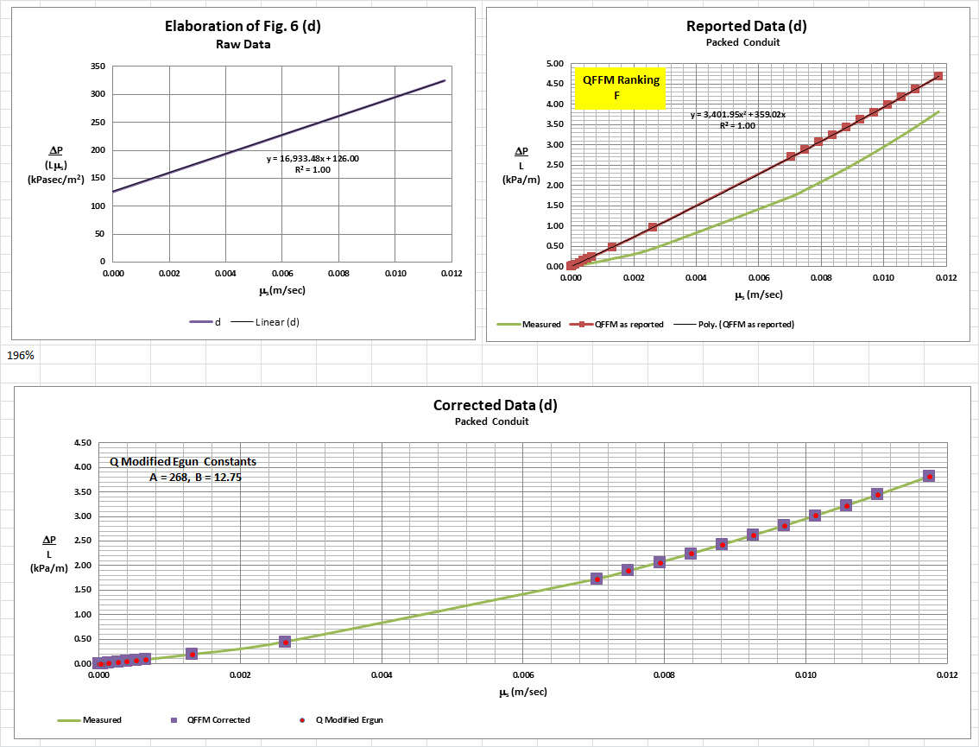

In the case of experiment d, our analysis demonstrates that the particles were even more irregular in shape (p = 0.157), which is 9 % lower than reported. The external porosity was 64.7%, which is 17 % larger than that reported by the authors. Note that the conduit to particle diameter ratio (D/dpm) = 6 was increasingly lower corresponding to an increasingly higher coefficient value of 20.7 for w in the QFFM. Finally, although our identified Q modified Ergun constants are 268 and 12.75 for A and B, respectively, there was an increasingly higher kinetic contribution to energy dissipation in this experiment because the upper flow rate measurements were taken in the transitional region of the fluid flow regime and, in addition, there was a significant secondary wall effect.

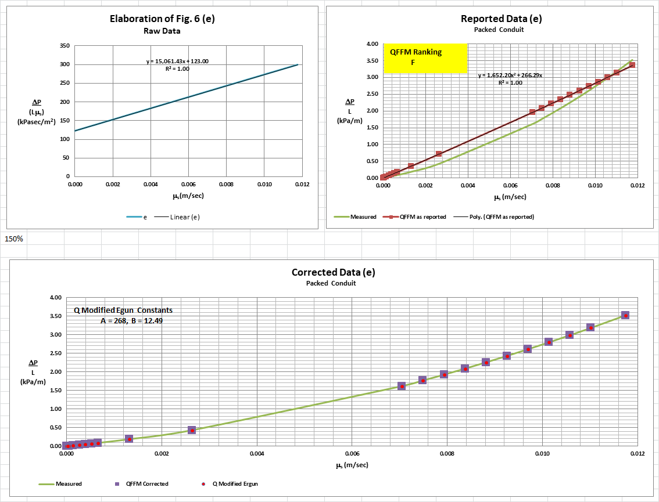

In the case of experiment e, our analysis demonstrates that the particles were highly irregular in shape (p = 0.086), which is 9 % lower than reported. The external porosity was 68.5%, which is 13 % larger than that reported by the authors. Note that conduit to particle diameter ratio (D/dpm) = 4 was increasingly lower corresponding to an increasingly higher coefficient value of 24.2 for w in the QFFM. Finally, although our identified Q modified Ergun constants are 268 and 12.49 for A and B, respectively, there was an increasingly higher kinetic contribution to energy dissipation in this experiment because the upper flow rate measurements were taken in the transitional region of the fluid flow regime and, in addition, there was a significant secondary wall effect.

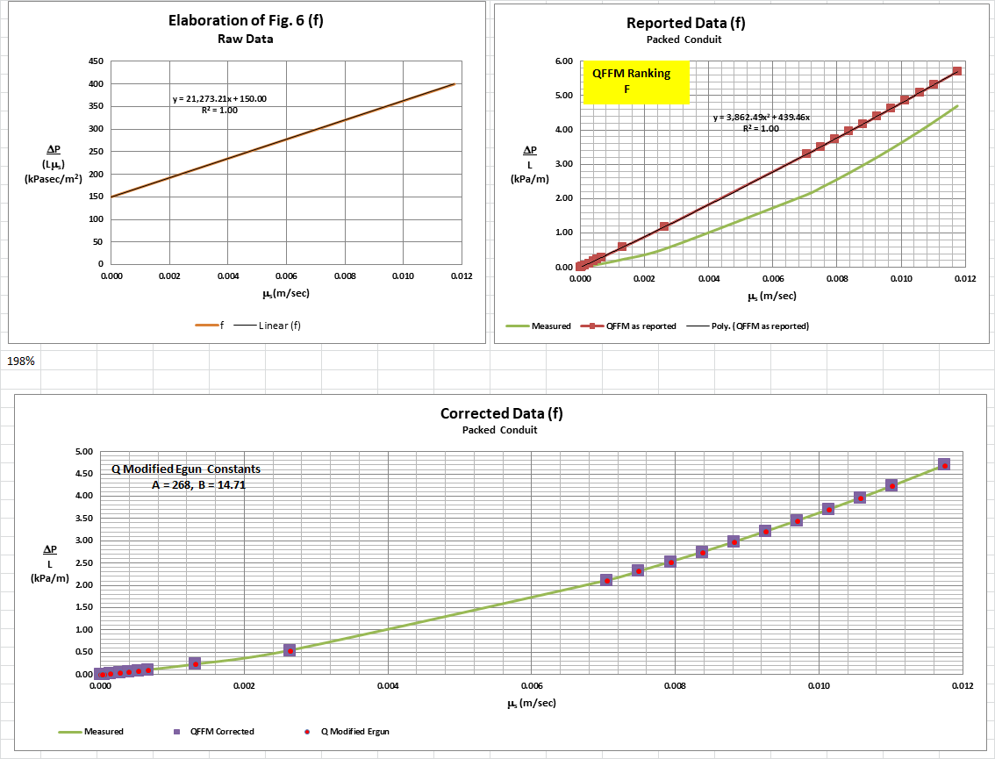

In the case of experiment f, our analysis demonstrates that the particles were, again, highly irregular (p = 0.163), which is 9 % lower than reported. The external porosity was 64.7%, which is 25 % larger than that reported by the authors. Note that the conduit to particle diameter ratio (D/dpm) = 7 was slightly higher corresponding to a slightly lower coefficient value of 24.1 for w in the QFFM. Finally, although our identified Q modified Ergun constants are 268 and 14.71 for A and B, respectively, there was significant kinetic contribution to energy dissipation in this experiment because the upper flow rate measurements were taken in the transitional region of the fluid flow regime and, in addition, there was a significant secondary wall effect.

1. **Corrected Data Reduced Parameters-Quinn’s Law**

In Fig. B herein, we have provided our validation of the papers’ corrected data by a comparison of the data to Quinn’s Law. This normalized relationship is presented herein in the form of a plot of PQ versus CQ, whichis the frame of reference of Quinn’s Law. This frame of reference is a transformation derived from the dimensional fluid flow relationship embedded in the QFFM. The relationship between these two unique reduced Quinn parameters is *linear*. However, we chose to present it as a *log-log plot* herein to provide emphasis at both extremes of the fluid flow regime. This plot is based upon both our own experimental data and *independent accepted classical reference data* which cover flow in both packed and empty conduits, over the entire fluid flow regime. (Note that the three distinct flow regimes of laminar, transitional and turbulent are clearly marked in the log-log plot.) As can be seen, the data reported in this paper, as corrected and as displayed in the form of a plot of PQ versus CQ , lines up perfectly with Quinn’s Law.

**Fig. B**

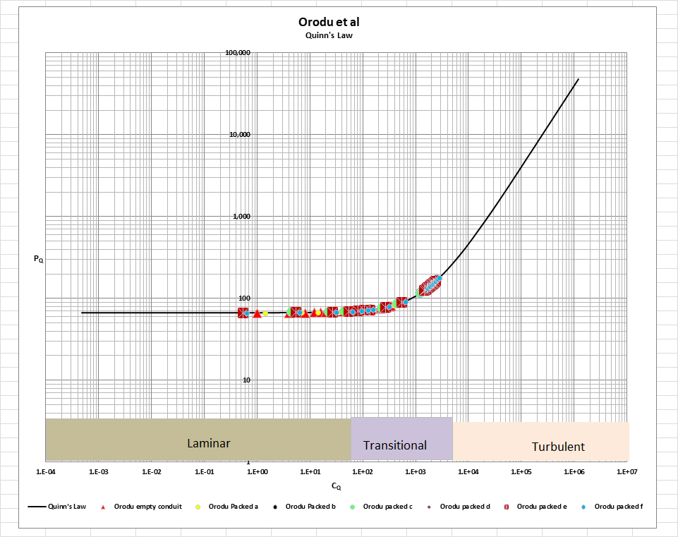

[Note: we do not herein provide the back-up for the validation of the plot of Quinn’s Law depicted in our Fig. B. For a description of the sources, both personal to TWG and from independent accepted classical references, on the basis of which the Quinn’s Law plot was validated, see the general introduction to this Universal Published Paper Review tab]

**Conclusion.**

We conclude that the measurement technique used by the authors suffered from major deficiencies related to accuracy and precision. Accordingly, based upon our ranking system, we assign the failing rank of F for all 6 experiments, which we deem to be a totally unacceptable level of measurement performance.

Accordingly, there is a mismatch between the measured values related to particle morphology, the reported values for column external porosity and the measured pressure drop and flow rates. This mismatch is only *apparent and quantifiable* in the context of the QFFM and, therefore, can only be corrected using this model. The QFFM follows a rigid procedure of establishing the value of underlying variables *independently* in the laminar, transitional and fully turbulent regimes, a technique which results in a single analytical solution. Accordingly, since the authors did not have access to Quinn’s Law when they wrote the paper, they *could not have* corrected the data before attempting to present it in the published paper. The inherent tendency to *modify* existing equations to correlate *unsubstantiated* empirical measurements has long since contributed to the confusion that exists in this field of study and has had a tendency to create the *false illusion* that these so-called conventional equations are of some *value* when, in reality, they are nothing more than *invalid* relationships.

In addition, the authors suggested in their discussions in the paper that the so-called “wall effect” might play a significant role in the 6 experiments reported in the paper and that this phenomenon was reflected in their modified Ergun values of 133 and 2.84 for the constants A and B, respectively, reported for their “test case” spherical particle experiment, which we have given the designation of “a” herein. (No modified Ergun constants were identified by the authors for the remaining 5 experiments in the paper). To the extent that the wall effect is defined as the effect upon conduit permeability when large particles are packed in a small conduit – as reflected in the ratio of the conduit to particle diameter - and, thus, the porosity of the conduit is materially larger near the wall than it is in the center of the bed, we can state that this “primary” wall effect played no part in the authors’ derivation of what is an erroneous value for the Ergun viscous constant. This is because the impact of the wall effect on viscous contributions to energy dissipation is manifested *completely* in an increased external porosity value. Consequently, the value of the viscous constant remains unchanged. In other words, its value in the Q modified Ergun model is *always* 268.

The QFFM correctly captures the impact of the above-described wall effect upon viscous contributions to energy dissipation *and,* since conduit external porosity also contributes to kinetic energy dissipation, the model likewise captures the impact in its kinetic term. However, unlike the Ergun model (but similar to the Nikuradze model), the QFFM additionally captures in its kinetic term a completely separate “wall effect” which contributes to pressure drop and which we designate the “secondary” wall effect: the *degree of roughness* of the conduit wall in an empty conduit and its “particle roughness profile” counterpart which undoubtedly prevails in the packed conduit under study. Therefore, when the conduit in which a packed bed is formed has an inner wall which is *not* hydraulically smooth and/or this is coupled with the particle roughness profile of the particles of the bed, the secondary type of wall effect manifests itself, but only as a kinetic contribution. Therefore, in this latter scenario, the kinetic contribution can contain both an increased external porosity component as well as a wall roughness component. It is worth pointing out that a fundamental flaw found in all empirical equations which do not have a kinetic term, such as the Kozeny/Carman equation, is that neither of these two components is recognized but this weakness *cannot* be overcome by adjusting the *inherent* value of the viscous constant in that model.

Since *all* the experiments in this paper involved fluid flow regimes of laminar and transitional, significant kinetic contributions to pressure drop were involved in all of them. As the conduit to particle ratio varied from experiment to experiment, the impact of the primary wall effect is reflected in the results. On the other hand, the QFFM reveals that because the inner wall of the conduit under study in the 6 experiments was made of Perspex plastic, which is not hydraulically smooth, in combination with the ever increasing irregular morphology of the particles, the secondary type of wall effect had an ever-increasing impact on the measured pressure drop as the conduit to particle diameter ratio became smaller and more of the wall surface was exposed to the flowing fluid.

Finally, although a detailed evaluation of the experiments reported in the paper under review, including an identification and quantification of the specific variables in each fluid flow embodiment which we claim the QFFM prescribes need to be corrected, is clearly within the capability of TWG, concerns about maintaining the confidentiality of the QFFM and Quinn’s Law – which, at this time, are still proprietary - dictate that such a development is premature.