**Universal Published Paper Review**

Introduction

The Quinn Fluid Flow Model (QFFM) is a totally new and novel theory of fluid dynamics in closed conduits. The underlying intellectual property is owned by The Wrangler Group LLC (TWG). It has been developed from first principles and applies to fluid flow in both packed and empty conduits across the entire fluid flow regime including laminar, transitional and turbulent. The model has been validated by applying it to classic studies in both categories of flow embodiments and, in each case, to studies in all fluid flow regimes.

The QFFM can be expressed in two formats. The first format is a dimensional manifestation in which the measured differential pressure across the ends of a conduit is compared to the measured resultant flow rate of the fluid according to the relationships dictated by the model among the many independent and dependent variables pertaining to the physical fluid flow embodiment and pertaining to the fluid itself. The second format is a dimensionless manifestation, which we call Quinn’s Law, where all the individual respective contributions to the pressure drop/fluid flow relationship have been normalized between the model’s two entities, which we call the “Quinn reduced pressure” and the “fluid current” and which we denote with the symbols PQ and Qc, respectively.

Any given combination of the underlying variables prescribed by the QFFM will have a unique pressure drop at any given flow rate. Accordingly, the QFFM is capable of distinguishing between *valid* and *invalid* data. In particular, the QFFM can identify a mismatch between a practitioner’s statement of the values he/she claims to have measured or calculated for the QFFM variables and the practitioner’s measured flow rate and pressure drop. We consider any mismatch to be an *invalid* empirical result. It follows that for every *invalid* empirical result there is but one *valid* corrected result.

Before one can apply Quinn’s Law to any given empirical result that result has to be validated using the dimensional manifestation of the QFFM. This, in turn, is because one cannot normalize properly for all the individual respective contributions unless all the variables are correctly identified and their values are commensurate with the measured pressure drops and fluid flow rates. In general, we can state that since most of the underlying variables pertaining to a fluid flow embodiment are relatively easy to measure, the correction usually pertains to the more difficult-to-measure variables. In the case of a packed conduit, the problematical measurements include particle sphericity, average particle diameter and conduit external porosity, In the case of an empty conduit, the weak link in terms of measurability is the conduit’s inner wall roughness.

QFFM is a unique and powerful new tool in the arsenal of the fluid flow practitioner. In particular, when experiments are conducted in the transitional and/or turbulent regimes, the conventional methodology does not provide any reliable way to verify the accuracy of the results across a broad spectrum of Reynolds numbers. Thus, it is in these regions of the fluid flow regime that the QFFM will be shown to be most useful. In fact, it is a direct consequence from the statements contained herein that one needs only to measure pressure drop and fluid flow rate to evaluate the quality of one’s experimental technique. This new development in fluid dynamics means that those of us who have spent our entire lives doing fluid flow measurements can now enjoy the same benefits as our counterparts within the field of electricity and magnetism.

Paper Summary

We review here a published article in **Journal of Hydrology 374 (2009) 242–254** entitled **Experimental investigation of inertial flow processes in porous media**,by **Moupsopoulos et al**. For easy reference to the reader, we print here in its entirety the abstract in the paper.

**Paper Abstract**

The hydraulic behavior of inertial flows in porous media is experimentally investigated. A vertical metal

column was constructed, of dimensions 0.5 m in diameter and 2.30 m in height. Eight different porous

media were used in the experiments. Head loss was measured. A total of 454 experimental data were collected. The experimental data indicate that, for a wide spectrum of velocities, both the Forchheimer and Izbash equations offer excellent descriptions of the flow processes. For moderate values of the Reynolds number, a discontinuity in the velocity–hydraulic gradient curve was detected, a behavior also predicted by former numerical studies. The analysis of the hydraulic behavior of bidisperse media indicate the influence of wall effects taking place at the interface between small and large grains. The data are used to validate semi-empirical relations, and give also some insight on the flow processes taking place at the pore-scale for the case of non-Darcian flows.

**Data Analysis**

TWG has performed an extensive evaluation of the above referenced published article utilizing the QFFM. We commence our evaluation of the paper with an in-depth analysis of the reported data.

In our Fig A-1 herein, we show our analysis of the reported dataset containing the packed conduits labeled M1 through M8 by providing an elaboration of Fig. 3 through Fig. 10 in the paper. In our elaborated plots, in addition to the reported measured data we include our QFFM corrected data which is generated by our application of the QFFM. The data has been corrected with respect to two parameters, namely spherical particle diameter equivalent (dp50) and external porosity (0).

The QFFM rejects the use of the particle based Reynolds number (Rep) because it does not recognize the contribution of the external porosity within the packed conduit. Instead we use the modified Reynolds number (Rem) as taught by Ergun because including the external porosity of the column is a necessity in applying the continuity equation to fluid flow through packed conduits. In addition, because the particles used in this data set are highly irregular the unique combination of spherical particle diameter equivalent and external porosity must be identified to properly determine the individual contributions from viscous and kinetic contributions, respectively, to the overall hydraulic gradient.

As can be seen from our Fig. A-1, the fit between the corrected data and the measured data sets is excellent for all the conduits with the exception of M1. In the case of this particular packed column we believe the discrepancy is due to measurement error. However, because we do not have access to the measured flow rates and temperature of the fluid (water), two necessary variables within the QFFM, we cannot be any more specific in our conclusions concerning this particular discrepancy.

In our Fig. A-2 we show an elaboration of Fig. 11 in the paper. We are careful not to include a logarithmic scale on the x axis as well as including *all* the data points, however, in order to maintain transparency.

In our Fig A-3, we provide our QFFM corrected data as a Q modified Ergun type equation. In this plot we identify the viscous and kinetic coefficients as the intercept and slope of the straight lines, respectively. As shown in the plot these values have an average of 268 and 2.57, respectively, for the entire data set.

In our Fig. A-4 we show a table which contains our corrected values for the spherical particle diameter equivalent, the external porosity and the modified Reynolds number.

Fig. A-1

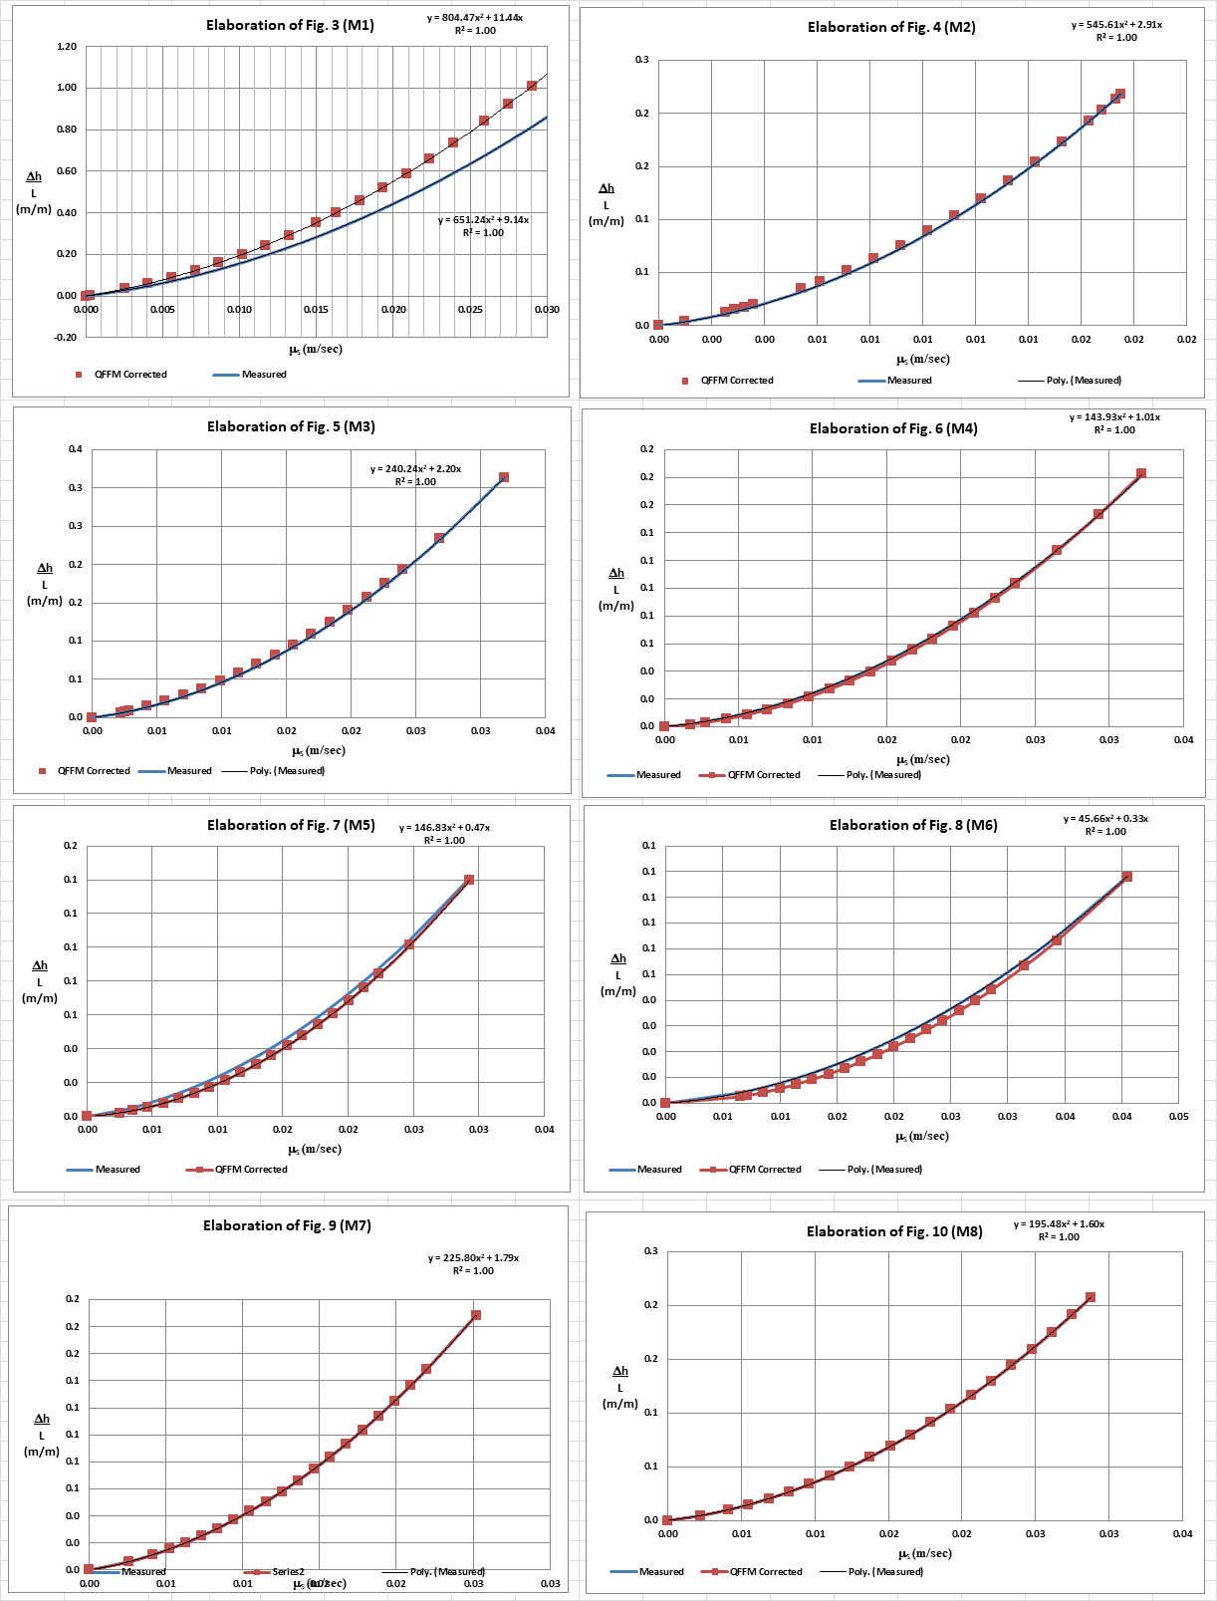

Fig. A-2

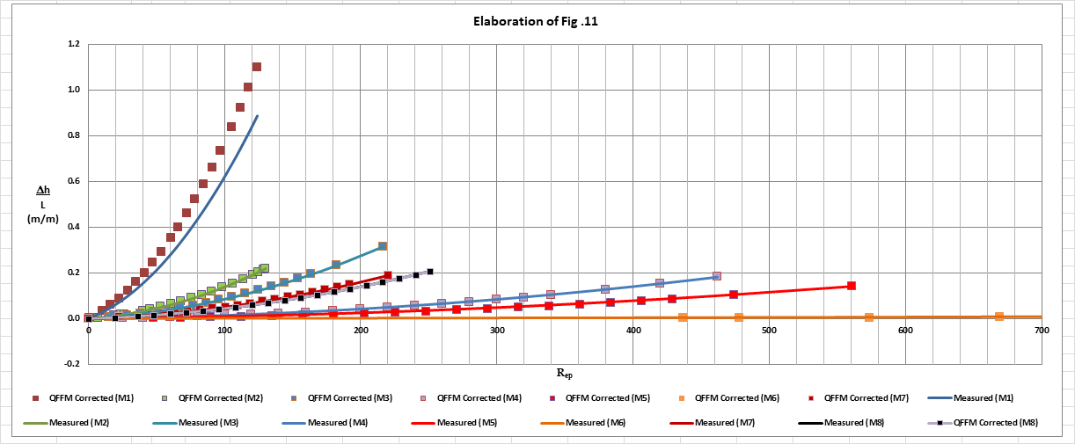

Fig. A-3

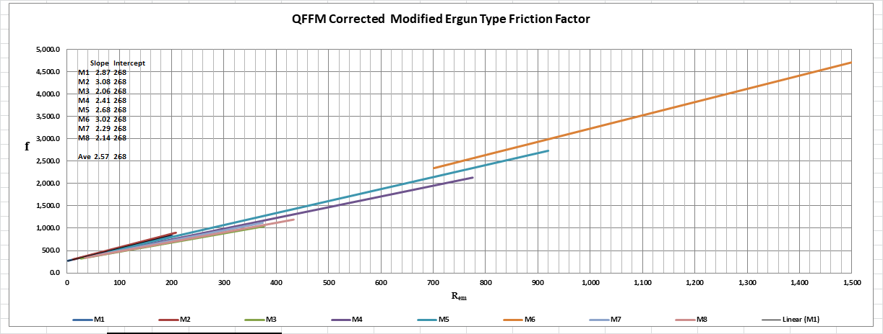

Fig. A-4

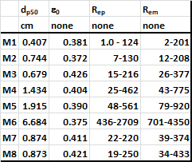

In Fig. B herein, we have provided our validation of the papers corrected data by a comparison of the data to Quinn’s Law. This normalized relationship is presented herein in the form of a plot of PQ versus QC, whichis the frame of reference of Quinn’s Law. This frame of reference is a transformation derived from the dimensional fluid flow relationship embedded in the QFFM. The relationship between these two unique reduced Quinn parameters is *linear*. However, we chose to present it as a *log-log plot* herein to provide emphasis at both extremes of the fluid flow regime. This plot is based upon both our own experimental data and *independent accepted classical reference data* which cover flow in both packed and empty conduits, over the entire fluid flow regime. (Note that the three distinct flow regimes of laminar, transitional and turbulent are clearly marked in the log-log plot.) As can be seen, the data reported in this paper, as corrected and as displayed in the form of a plot of PQ versus QC , lines up perfectly with Quinn’s Law

**Fig. B**

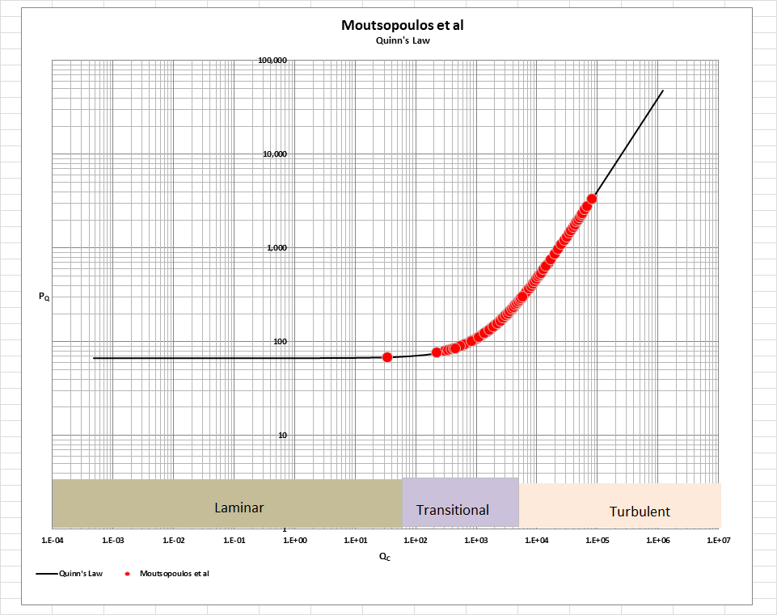

[Note: we do not herein provide the back-up for the validation of the plot of Quinn’s Law depicted in our Fig. B. For a description of the sources, both personal to TWG and from independent accepted classical references, on the basis of which the Quinn’s Law plot was validated, see the general introduction to this Universal Published Paper Review tab.

**Conclusion.**

We conclude that the measurement technique used by the authors suffered from deficiencies related to accuracy and precision which were undoubtedly exacerbated by the highly irregular nature of the particles used. In addition, the authors failed to properly apply the Laws of Continuity in addition to their efforts to align their measured data with conventional empirical permeability equations. We are not convinced by the authors arguments concerning the point of discontinuity of the boundary layer suggested as a basis for the discrepant data of column M1. Our opinion is bolstered by our belief that in this packed conduit the boundary layer is infinitesimally thin over the entire range of modified Reynolds numbers covered by the measurements.

Accordingly, there is a mismatch between the apparent measured values for spherical particle diameter equivalent, the reported values for column external porosity and the measured pressure drop and flow rates. This mismatch is only *apparent and quantifiable* in the context of the QFFM and, therefore, can only be corrected using this model. Accordingly, since the authors did not have access to Quinn’s Law when they wrote the paper, they *could not have* corrected the data before attempting to present it in the published paper. The inherent tendency to *modify* existing equations to correlate *unsubstantiated* empirical measurements has long since contributed to the confusion that exists in this field of study and has had a tendency to create the *false illusion* that these so-called conventional equations are of some *value* when, in reality, they are nothing more than *invalid* relationships.

Finally, although a detailed evaluation of the experiments reported in the paper under review, including an identification and quantification of the specific variables in each fluid flow embodiment which we claim the QFFM prescribes need to be corrected, is clearly within the capability of TWG, concerns about maintaining the confidentiality of the QFFM and Quinn’s Law – which, at this time, are still proprietary - dictate that such a development is premature.