Universal Published Paper Review

Introduction

The Quinn Fluid Flow Model (QFFM) is a totally new and novel theory of fluid dynamics in closed conduits. The underlying intellectual property is owned by The Wrangler Group LLC (TWG). It has been developed from first principles and validated in both packed and empty conduits across the entire fluid flow regime including laminar, transitional and turbulent. The validation is made up of classic studies in both categories of flow embodiments. The QFFM is applied in two formats; a dimensional manifestation in which differential pressure across the ends of a conduit is related to the resultant flow rate of the fluid through the many independent and dependent variables pertaining to the physical fluid flow embodiment as well as the fluid itself; a dimensionless manifestation which we call Quinn’s Law in which various contributions have been normalized for between the two entities of, PQ, the normalized pressure and, Qc, the fluid current.

This is the only extant theoretical/empirical equation which has been validated in both packed and empty conduits across the entire Reynolds number spectrum. Accordingly, it is the only fluid flow model capable of distinguishing between *valid* and *invalid* experimental data results. What we mean by this is that any given combination of the underlying variables mentioned above will produce a unique pressure drop at any given flow rate. Because the QFFM has been validated against the empirical gold standard classical studies, it is capable of identifying a mismatch between the measured variables and the measured flow rate and pressure drop. We consider any mismatch to be an *invalid* empirical result. It follows that for every *invalid* empirical result there is but one *valid* corrected result. In general, we can state that since most of the underlying variables pertaining to a fluid flow embodiment are relatively easy to measure, the correction usually pertains to the more difficult to measure variables of particle sphericity, average particle diameter and conduit external porosity, in the case of a packed conduit, and inner wall roughness in the case of an empty conduit. It is vital that before one can apply Quinn’s Law to any given empirical result, that result has to be validated using the dimensional manifestation of the QFFM. This, in turn, is because one cannot normalize properly for all individual contributions unless all the variables are correctly identified and their *values* are commensurate with the measured pressure drop.

It is clear from above that the QFFM is a unique and powerful new tool in the arsenal of the fluid flow practitioner. In particular, when experiments are conducted in the transitional and/or turbulent regimes, the conventional methodology does not provide any reliable methodology across a broad spectrum of Reynolds numbers. It is in these regions of the fluid flow regime that the QFFM will be shown to be most useful. In fact, it is a direct consequence from the statements contained herein that one needs only to measure pressure drop now to evaluate the quality of one’s experimental technique. This new development in fluid dynamics means that those of us who have spent our entire lives doing fluid flow measurements can now enjoy the same benefits as that of our counterparts within the field of electricity and magnetism.

**Paper Summary**

In a published article in Transp Porous Med (2017) 116: 413-431***,*** entitled ***Measurements of transitional and Turbulent Flow in a Randomly Packed Bed of Spheres with Particle Image Velocimetry*** the authors, **Lundstrom et al**, concluded as follows; “ PIV measurements have been conducted for 20≤ Rep ≤ 3220 within a refractive index-matched packed bed of mono-sized spheres”. For easy reference to the reader, we print here in its entirety the paper abstract.

**Paper Abstract**

Particle image velocimetry (PIV) has been used to investigate transitional and turbulent flow in a randomly packed bed of mono-sized transparent sphered at particle Reynolds number, 20 ≤ Rep ≤ 3220. The refractive index of the liquid is matched with the spheres to provide optical access to the flow within the bed without distortions. Integrated pressure drop data yield that Darcy law is valid Rep ∿ 80. The PIV measurements show that the velocity fluctuations increase and that the time-averaged velocity distribution start to change at lower Rep. The probability for relatively low and high velocities decreases with Rep and recirculation zones that appear in inertia dominated flows are suppressed by the turbulent flow at higher Rep. Hence there is a maximum of recirculation at about Rep ∿ 400. Finally, statistical analysis of the spatial distributions of time-averaged velocities shows that the velocity distribution is clearly and weakly self-similar with respect to Rep for turbulent and laminar flow, respectively.

TWG has performed an extensive evaluation of the above referenced published article utilizing the QFFM. We commence our evaluation of the paper with an in depth analysis.

**Data Analysis**

In our Fig. 1 herein, we show our calculated results for pressure drop based upon the information provided in the paper. We are somewhat surprised that the authors did not provide the measured pressure drop data in a meaningful format in the paper but rather instead opted for a detailed plot of calculated superficial and interstitial velocity. Accordingly, we cannot determine precisely if there is a mismatch in the reported data due to measurement technique deficiencies.

Fig. 1

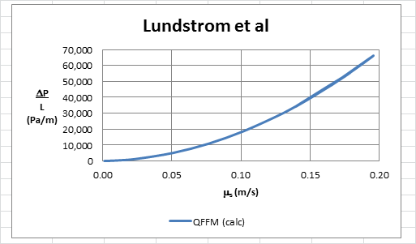

In Fig. B herein, we have provided our validation of the papers corrected data by a comparison of the data to Quinn’s Law. This normalized relationship is presented herein in the form of a plot of PQ versus QC, whichis the frame of reference of Quinn’s Law. This frame of reference is a transformation derived from the dimensional fluid flow relationship embedded in the QFFM. The relationship between these two unique reduced Quinn parameters is *linear*. However, we chose to present it as a *log-log plot* herein to provide emphasis at both extremes of the fluid flow regime. This plot is based upon both our own experimental data and *independent accepted classical reference data* which cover flow in both packed and empty conduits, over the entire fluid flow regime. (Note that the three distinct flow regimes of laminar, transitional and turbulent are clearly marked in the log-log plot.) As can be seen, the data reported in this paper, as corrected and as displayed in the form of a plot of PQ versus QC , lines up perfectly with Quinn’s Law

Fig.B

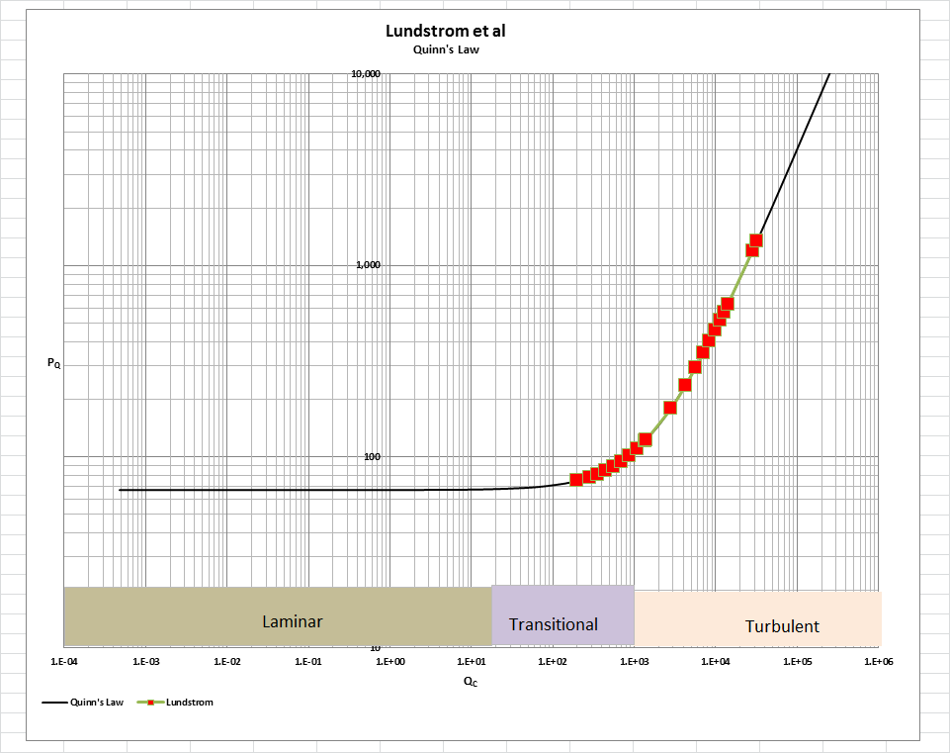

[Note: we do not herein provide the back-up for the validation of the plot of Quinn’s Law depicted in our Fig. B. For a description of the sources, both personal to TWG and from independent accepted classical references, on the basis of which the Quinn’s Law plot was validated, see the general introduction to this Universal Published Paper Review tab.

**Conclusion.**

We conclude that the results in this paper are consistent with those calculated using QFFM.

Finally, although a detailed evaluation of the experiments reported in the paper under review, including an identification and quantification of the specific variables in each fluid flow embodiment which we claim the QFFM prescribes need to be corrected, is clearly within the capability of TWG, concerns about maintaining the confidentiality of the QFFM and Quinn’s Law – which, at this time, are still proprietary - dictate that such a development is premature.