**Universal Published Paper Review**

Introduction

The Quinn Fluid Flow Model (QFFM) is a totally new and novel theory of fluid dynamics in closed conduits. The underlying intellectual property is owned by The Wrangler Group LLC (TWG). It has been developed from first principles and applies to fluid flow in both packed and empty conduits across the entire fluid flow regime including laminar, transitional and turbulent. The model has been validated by applying it to classic studies in both categories of flow embodiments and, in each case, to studies in all fluid flow regimes.

The QFFM can be expressed in two formats. The first format is a dimensional manifestation in which the measured differential pressure across the ends of a conduit is compared to the measured resultant flow rate of the fluid according to the relationships dictated by the model among the many independent and dependent variables pertaining to the physical fluid flow embodiment and pertaining to the fluid itself. The second format is a dimensionless manifestation, which we call Quinn’s Law, where all the individual respective contributions to the pressure drop/fluid flow relationship have been normalized between the model’s two entities, which we call the “Quinn reduced pressure” and the “fluid current” and which we denote with the symbols PQ and Qc, respectively.

Any given combination of the underlying variables prescribed by the QFFM will have a unique pressure drop at any given flow rate. Accordingly, the QFFM is capable of distinguishing between *valid* and *invalid* data. In particular, the QFFM can identify a mismatch between a practitioner’s statement of the values he/she claims to have measured or calculated for the QFFM variables and the practitioner’s measured flow rate and pressure drop. We consider any mismatch to be an *invalid* empirical result. It follows that for every *invalid* empirical result there is but one *valid* corrected result.

Before one can apply Quinn’s Law to any given empirical result that result has to be validated using the dimensional manifestation of the QFFM. This, in turn, is because one cannot normalize properly for all the individual respective contributions unless all the variables are correctly identified and their values are commensurate with the measured pressure drops and fluid flow rates. In general, we can state that since most of the underlying variables pertaining to a fluid flow embodiment are relatively easy to measure, the correction usually pertains to the more difficult-to-measure variables. In the case of a packed conduit, the problematical measurements include particle sphericity, average particle diameter and conduit external porosity, In the case of an empty conduit, the weak link in terms of measurability is the conduit’s inner wall roughness.

QFFM is a unique and powerful new tool in the arsenal of the fluid flow practitioner. In particular, when experiments are conducted in the transitional and/or turbulent regimes, the conventional methodology does not provide any reliable way to verify the accuracy of the results across a broad spectrum of Reynolds numbers. Thus, it is in these regions of the fluid flow regime that the QFFM will be shown to be most useful. In fact, it is a direct consequence from the statements contained herein that one needs only to measure pressure drop and fluid flow rate to evaluate the quality of one’s experimental technique. This new development in fluid dynamics means that those of us who have spent our entire lives doing fluid flow measurements can now enjoy the same benefits as our counterparts within the field of electricity and magnetism.

Paper Summary

We review here a published article in ***Eleventh International Conference on CFD in the Minerals and Process Industries CSIRO, Melbourne, Australia***, **7-9 Dec 2015,** entitled **NUMERICAL VALIDATION OF THE EISFELD AND SCHNITZLEIN PRESSURE**

**DROP CORRELATION FOR SMALL ASPECT RATIO PACKED BEDS**,by **Kruger et al**. For easy reference to the reader, we print here in its entirety the abstract in the paper.

**Paper Abstract**

Packed beds consisting of spherical particles are widely used in the minerals and process industries, with typical applications ranging from chemical reactors to nuclear heat generation. The pressure drop of a fluid flowing through the packed bed is of critical importance for the successful design and operation of installations. Four factors mainly influence the pressure drop: the fluid and flow properties typically characterized by the Reynolds number, the porous structure and the bed geometry, typically characterized amongst others by the aspect ratio. With small aspect ratio (ratio between cylinder diameter and particle diameter) beds, it was further found that the vessel walls affect the porous structure close to the boundaries. This leads to significant "wall effects" involving the local flow resistance and heat

Transfer processes between the bed and vessel walls. The Eisfeld and Schnitzlein (ES) correlation is a popular Ergun-type correlation used to predict the pressure drop over packed beds with small aspect ratios. The parameters of the ES correlation were derived from an in-depth analysis of results from a large number of experiments conducted using suitable bed geometries. To validate the ES correlation numerically, a CFD based methodology was developed in this study. Packed beds with different aspect ratios were packed with spheres using the Discrete Element Method (DEM) and the interstitial spaces between spheres were discretized to obtain the numerical flow domain. From the CFD simulations, the pressure drops and friction factors over the beds were obtained, which were subsequently compared with the values predicted by the ES correlation. Excellent agreement was found between the ES correlation and numerical results for the range of Reynolds numbers and aspect ratios investigated. This increased confidence in the numerical methodology as well as in the use of the ES correlation to predict the pressure drop of turbulent flow over packed beds with small aspect ratios

**Data Analysis**

TWG has performed an extensive evaluation of the above referenced published article utilizing the QFFM. We commence our evaluation of the paper with an in-depth analysis of the reported data.

As shown in our Fig. A-1, we have created a replica of Fig. 7a and 7b in the paper, using the QFFM. The QFFM is a comprehensive model which automatically compensates for “wall effects” and accordingly, has no difficulty returning calculated values for measured pressure drops taken in packed conduits with a conduit diameter to particle diameter ratio of 2.01 ( = 2.01). As can be seen in our Fig.A, when compared to the data in Fig. 7a and 7b, we have captured exactly the information presented in the paper.

As shown in our Fig. A-2, we have presented the calculated results using the QFFM which are similar in nature to the data presented in Fig. 8 in the paper for packed conduits of varying but very low values of conduit diameter to particle ratios (alpha values).

**Fig. A-1**

**Fig. A-2**

In Fig. B herein, we have provided our validation of the papers corrected data by a comparison of the data to Quinn’s Law. This normalized relationship is presented herein in the form of a plot of PQ versus QC, whichis the frame of reference of Quinn’s Law. This frame of reference is a transformation derived from the dimensional fluid flow relationship embedded in the QFFM. The relationship between these two unique reduced Quinn parameters is *linear*. However, we chose to present it as a *log-log plot* herein to provide emphasis at both extremes of the fluid flow regime. This plot is based upon both our own experimental data and *independent accepted classical reference data* which cover flow in both packed and empty conduits, over the entire fluid flow regime. (Note that the three distinct flow regimes of laminar, transitional and turbulent are clearly marked in the log-log plot.) As can be seen, the data reported in this paper, as corrected and as displayed in the form of a plot of PQ versus QC , lines up perfectly with Quinn’s Law

**Fig. B**

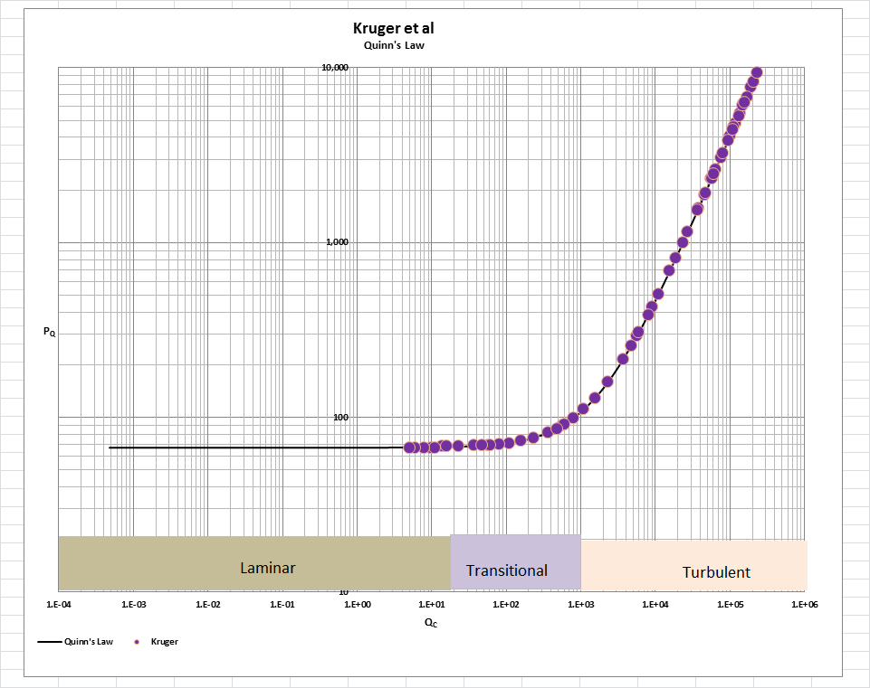

[Note: we do not herein provide the back-up for the validation of the plot of Quinn’s Law depicted in our Fig. B. For a description of the sources, both personal to TWG and from independent accepted classical references, on the basis of which the Quinn’s Law plot was validated, see the general introduction to this Universal Published Paper Review tab.

**Conclusion.**

We conclude that the results in this paper are consistent with those calculated using QFFM.

Finally, although a detailed evaluation of the experiments reported in the paper under review, including an identification and quantification of the specific variables in each fluid flow embodiment which we claim the QFFM prescribes need to be corrected, is clearly within the capability of TWG, concerns about maintaining the confidentiality of the QFFM and Quinn’s Law – which, at this time, are still proprietary - dictate that such a development is premature.