**Universal Published Paper Review**

Introduction

The Quinn Fluid Flow Model (QFFM) is a totally new and novel theory of fluid dynamics in closed conduits. The underlying intellectual property is owned by The Wrangler Group LLC (TWG). It has been developed from first principles and applies to fluid flow in both packed and empty conduits across the entire fluid flow regime including laminar, transitional and turbulent. The model has been validated by applying it to classic studies in both categories of flow embodiments and, in each case, to studies in all fluid flow regimes.

The QFFM can be expressed in two formats. The first format is a dimensional manifestation in which the measured differential pressure across the ends of a conduit is compared to the measured resultant flow rate of the fluid according to the relationships dictated by the model among the many independent and dependent variables pertaining to the physical fluid flow embodiment and pertaining to the fluid itself. The second format is a dimensionless manifestation, which we call Quinn’s Law, where all the individual respective contributions to the pressure drop/fluid flow relationship have been normalized between the model’s two entities, which we call the “Quinn reduced pressure” and the “fluid current” and which we denote with the symbols PQ and Qc, respectively.

Any given combination of the underlying variables prescribed by the QFFM will have a unique pressure drop at any given flow rate. Accordingly, the QFFM is capable of distinguishing between *valid* and *invalid* data. In particular, the QFFM can identify a mismatch between a practitioner’s statement of the values he/she claims to have measured or calculated for the QFFM variables and the practitioner’s measured flow rate and pressure drop. We consider any mismatch to be an *invalid* empirical result. It follows that for every *invalid* empirical result there is but one *valid* corrected result.

Before one can apply Quinn’s Law to any given empirical result that result has to be validated using the dimensional manifestation of the QFFM. This, in turn, is because one cannot normalize properly for all the individual respective contributions unless all the variables are correctly identified and their values are commensurate with the measured pressure drops and fluid flow rates. In general, we can state that since most of the underlying variables pertaining to a fluid flow embodiment are relatively easy to measure, the correction usually pertains to the more difficult-to-measure variables. In the case of a packed conduit, the problematical measurements include particle sphericity, average particle diameter and conduit external porosity, In the case of an empty conduit, the weak link in terms of measurability is the conduit’s inner wall roughness.

QFFM is a unique and powerful new tool in the arsenal of the fluid flow practitioner. In particular, when experiments are conducted in the transitional and/or turbulent regimes, the conventional methodology does not provide any reliable way to verify the accuracy of the results across a broad spectrum of Reynolds numbers. Thus, it is in these regions of the fluid flow regime that the QFFM will be shown to be most useful. In fact, it is a direct consequence from the statements contained herein that one needs only to measure pressure drop and fluid flow rate to evaluate the quality of one’s experimental technique. This new development in fluid dynamics means that those of us who have spent our entire lives doing fluid flow measurements can now enjoy the same benefits as our counterparts within the field of electricity and magnetism.

Paper Summary

We review here a published article in**Fuel 158 (2015) 232-238** entitled **Effect of material type and particle size distribution on pressure drop in packed beds of large particles: Extending the Ergun equation**,by **Koekemoer et al**. For easy reference to the reader, we print here in its entirety the abstract in the paper.

**Paper Abstract**

The dependence of packed bed pressure drop on variables such as particle size distribution (PSD) and material type are of vital importance in the design of industrial equipment including fixed and fluidized-bed reactors, blast furnaces and fixed-bed gasifiers. The pressure drop across a packed bed is commonly calculated using the Ergun equation that was developed using experimental data from laboratory-scale beds comprised of small, mono-sized, non-porous, spherical or nearly spherical particles. In the industrial applications much larger poly-dispersed particles are used, raising the need for a correlation based on more relevant measurements. This study deals with an extension of the Ergun equation to packed beds of large coal, char and ash particles with different average particle diameters and different PSD widths. The research presented here has shown the influence of material type and PSD on both particle properties (sphericity) and packed bed properties (voidage and Sauter mean diameter). In turn these have a significant impact on the subsequent bed pressure drop. It was determined that a bed of ash particles has the highest voidage, followed by the char bed and then coal bed with the lowest voidage. The difference may be attributed to differences in particle sphericity as well as the surface roughness of the particles. In all cases the particle diameter had a lesser effect on bed voidage compared to PSD width, as wider PSD was associated with a lower bed voidage due to smaller particles filling the spaces between the larger particles. New value of the Ergun equation constants were obtained via regression analysis from pressure drop data generated for coal, ash and char particles. The values applicable to coal (77.4 and 2.8), char (160.4 and 2.8) and ash (229.7 and 2.3) particles were found to better accommodate bed pressure drop compared to those used in the original form of the Ergun equation (150 and 1.75). The modified Ergun equation can successfully be used to predict pressure drop in a composite packed bed of coal, char and ash particles mimicking the bed structure in an industrial packed-bed gasifier.

**Data Analysis**

TWG has performed an extensive evaluation of the above referenced published article utilizing the QFFM. We commence our evaluation of the paper with an in-depth analysis of the reported data.

In our Fig A-1 herein, we have plotted an elaboration of Fig. 5 in the paper but using the QFFM to correlate the measured variables with the measured pressure drop and flow rate. In addition, we have also expressed our results in terms of the Q modified Ergun type equation. As can be seen in our Fig. A-1, the correlation between the measured data and our calculated data using the QFFM is perfect.

In our Fig. A-2 herein, we show our calculated values for the data set including the values for the constants in the Q modified Ergun type equation. We point out that there are significant differences between our calculated numbers and those reported by the authors for many of the underlying variables.

Fig. A-1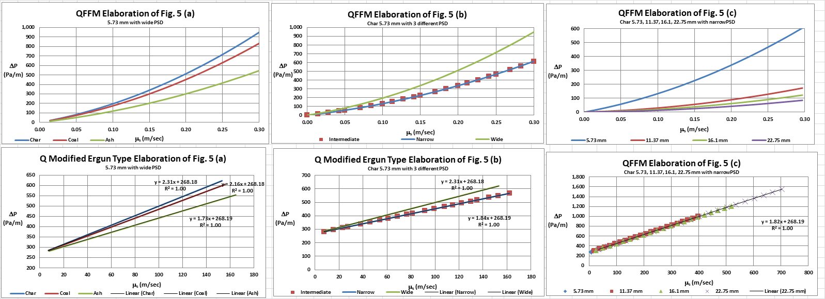

Fig. A-2

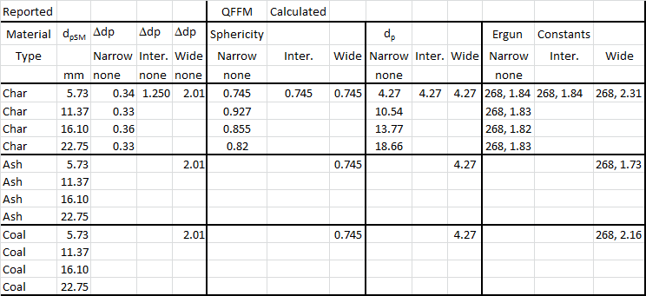

In Fig. B herein, we have provided our validation of the papers corrected data by a comparison of the data to Quinn’s Law. This normalized relationship is presented herein in the form of a plot of PQ versus QC, whichis the frame of reference of Quinn’s Law. This frame of reference is a transformation derived from the dimensional fluid flow relationship embedded in the QFFM. The relationship between these two unique reduced Quinn parameters is *linear*. However, we chose to present it as a *log-log plot* herein to provide emphasis at both extremes of the fluid flow regime. This plot is based upon both our own experimental data and *independent accepted classical reference data* which cover flow in both packed and empty conduits, over the entire fluid flow regime. (Note that the three distinct flow regimes of laminar, transitional and turbulent are clearly marked in the log-log plot.) As can be seen, the data reported in this paper, as corrected and as displayed in the form of a plot of PQ versus QC , lines up perfectly with Quinn’s Law

**Fig. B**

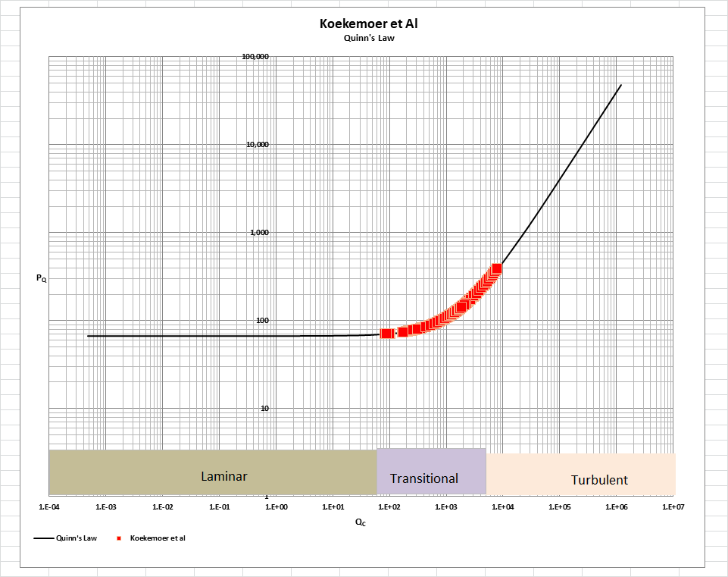

[Note: we do not herein provide the back-up for the validation of the plot of Quinn’s Law depicted in our Fig. B. For a description of the sources, both personal to TWG and from independent accepted classical references, on the basis of which the Quinn’s Law plot was validated, see the general introduction to this Universal Published Paper Review tab.

**Conclusion.**

We conclude that the measurement technique used by the authors suffered from deficiencies related to accuracy and precision. In addition, the authors failed to properly apply the Laws of Continuity in addition to their efforts to align their measured data with conventional empirical permeability equations.

Accordingly, there is a mismatch between the apparent measured values for spherical particle diameter equivalent, the reported values for column external porosity and the measured pressure drop and flow rates. This mismatch is only *apparent and quantifiable* in the context of the QFFM and, therefore, can only be corrected using this model. Accordingly, since the authors did not have access to Quinn’s Law when they wrote the paper, they *could not have* corrected the data before attempting to present it in the published paper. The inherent tendency to *modify* existing equations to correlate *unsubstantiated* empirical measurements has long since contributed to the confusion that exists in this field of study and has had a tendency to create the *false illusion* that these so-called conventional equations are of some *value* when, in reality, they are nothing more than *invalid* relationships.

Finally, although a detailed evaluation of the experiments reported in the paper under review, including an identification and quantification of the specific variables in each fluid flow embodiment which we claim the QFFM prescribes need to be corrected, is clearly within the capability of TWG, concerns about maintaining the confidentiality of the QFFM and Quinn’s Law – which, at this time, are still proprietary - dictate that such a development is premature.