**Universal Published Paper Review**

Introduction

The Quinn Fluid Flow Model (QFFM) is a totally new and novel theory of fluid dynamics in closed conduits. The underlying intellectual property is owned by The Wrangler Group LLC (TWG). It has been developed from first principles and applies to fluid flow in both packed and empty conduits across the entire fluid flow regime including laminar, transitional and turbulent. The model has been validated by applying it to classic studies in both categories of flow embodiments and, in each case, to studies in all fluid flow regimes.

The QFFM can be expressed in two formats. The first format is a dimensional manifestation in which the measured differential pressure across the ends of a conduit is compared to the measured resultant flow rate of the fluid according to the relationships dictated by the model among the many independent and dependent variables pertaining to the physical fluid flow embodiment and pertaining to the fluid itself. The second format is a dimensionless manifestation, which we call Quinn’s Law, where all the individual respective contributions to the pressure drop/fluid flow relationship have been normalized between the model’s two entities, which we call the “Quinn reduced pressure” and the “fluid current” and which we denote with the symbols PQ and Qc, respectively.

Any given combination of the underlying variables prescribed by the QFFM will have a unique pressure drop at any given flow rate. Accordingly, the QFFM is capable of distinguishing between *valid* and *invalid* data. In particular, the QFFM can identify a mismatch between a practitioner’s statement of the values he/she claims to have measured or calculated for the QFFM variables and the practitioner’s measured flow rate and pressure drop. We consider any mismatch to be an *invalid* empirical result. It follows that for every *invalid* empirical result there is but one *valid* corrected result.

Before one can apply Quinn’s Law to any given empirical result that result has to be validated using the dimensional manifestation of the QFFM. This, in turn, is because one cannot normalize properly for all the individual respective contributions unless all the variables are correctly identified and their values are commensurate with the measured pressure drops and fluid flow rates. In general, we can state that since most of the underlying variables pertaining to a fluid flow embodiment are relatively easy to measure, the correction usually pertains to the more difficult-to-measure variables. In the case of a packed conduit, the problematical measurements include particle sphericity, average particle diameter and conduit external porosity, In the case of an empty conduit, the weak link in terms of measurability is the conduit’s inner wall roughness.

QFFM is a unique and powerful new tool in the arsenal of the fluid flow practitioner. In particular, when experiments are conducted in the transitional and/or turbulent regimes, the conventional methodology does not provide any reliable way to verify the accuracy of the results across a broad spectrum of Reynolds numbers. Thus, it is in these regions of the fluid flow regime that the QFFM will be shown to be most useful. In fact, it is a direct consequence from the statements contained herein that one needs only to measure pressure drop and fluid flow rate to evaluate the quality of one’s experimental technique. This new development in fluid dynamics means that those of us who have spent our entire lives doing fluid flow measurements can now enjoy the same benefits as our counterparts within the field of electricity and magnetism.

Paper Summary

We review here a published article in the **Journal of Chromatography A, 1184 (2008) 393–415,** entitled **Particle packed columns and monolithic columns in high-performance liquid chromatography-comparison and critical appraisal,** by **K.K. Unger et al**. For easy reference to the reader, we print here in its entirety the abstract in the paper.

**Paper Abstract**

The review highlights the fundamentals and the most prominent achievements in the field of high-performance liquid chromatography (HPLC) column development over a period of nearly 50 years. After a short introduction on the structure and function of HPLC columns, the first part treats the major steps and processes in the manufacture of a particle packed column: synthesis and control of particle morphology, sizing and size analysis, packing procedures and performance characterization. The next section is devoted to three subjects, who reflect the recent development and the main future directions of packed columns: minimum particle size of packing, totally porous vs. core/shell particles and column miniaturization. In the last section an analysis is given on an alternative to packed columns—monolithic columns, which have gained considerable attraction. The challenges are: improved packing design based on modeling and simulation for targeted applications, and enhanced robustness and reproducibility of monolithic columns. In the field of miniaturization, particularly in chip-based nano-LC systems, monoliths offer a great potential for the separation of complex mixtures e.g. in life science.

**Data Analysis**

TWG has performed an extensive evaluation of the above referenced published article utilizing the QFFM. We commence our evaluation of the paper with an in-depth analysis of the reported data.

As shown in our Fig. A-1, we have created a plot of the data presented in Table 4 of the paper. We have used the QFFM to relate **all three** variants of the flow resistance parameter  it corresponding to superficial, interstitial and mobile phase velocity, respectively, for all column dimensions specified in the table. As shown in the plot, the y-axis contains the values of the flow resistance parameter  and is plotted as a function of the empty column volume, CEV, in mL, on the x-axis. The values for  range from a low for i of about 600, to about 1,000 for t, to 1500 for 0. Most references in the chromatographic literature for these type columns suggest a value of approximately 1,000 for t which confirms this analysis using QFFM.

**Fig. A-1**

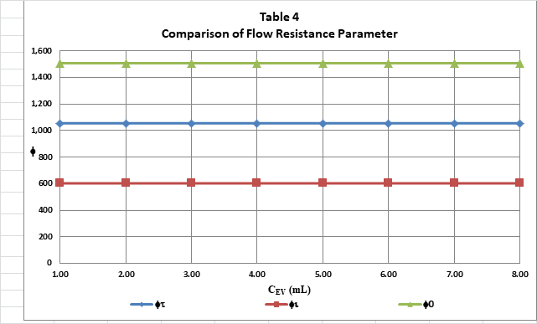

In Fig. B herein, we have provided our validation of the papers data by a comparison of the data to Quinn’s Law. This normalized relationship is presented herein in the form of a plot of PQ versus QC, whichis the frame of reference of Quinn’s Law. This frame of reference is a transformation derived from the dimensional fluid flow relationship embedded in the QFFM. The relationship between these two unique reduced Quinn parameters is *linear*. However, we chose to present it as a *log-log plot* herein to provide emphasis at both extremes of the fluid flow regime. This plot is based upon both our own experimental data and *independent accepted classical reference data* which cover flow in both packed and empty conduits, over the entire fluid flow regime. (Note that the three distinct flow regimes of laminar, transitional and turbulent are clearly marked in the log-log plot.) As can be seen, the data reported in this paper, in the form of a plot of PQ versus QC , lines up perfectly with Quinn’s Law

**Fig. B**

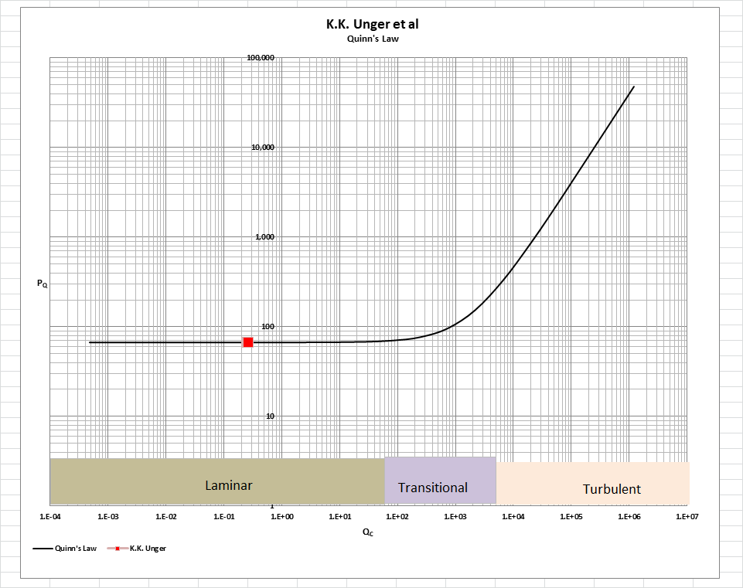

[Note: we do not herein provide the back-up for the validation of the plot of Quinn’s Law depicted in our Fig. B. For a description of the sources, both personal to TWG and from independent accepted classical references, on the basis of which the Quinn’s Law plot was validated, see the general introduction to this Universal Published Paper Review tab.

**Conclusion.**

We conclude that the results presented in Table 4 of this paper **independently confirm** Quinn’s Law.

This is particularly significant since this author recognizes that Professor Unger is one of the most senior and accomplished chromatographic experts currently living, particularly when it comes to the **design and engineering** of chromatographic particles, which was **his forte** throughout his long and distinguished active working life in the laboratory. In particular, the data presented in Table 4 shines light on the many discrepancies that has crept into packed bed permeabilities **in modern times** by the confusion that arose beginning after the major switch in the industry from gas to liquid chromatography, as a result of measurement technique. We are referring, of course, to the practice of injecting unretained solutes into packed columns containing partially porous particles to determine column porosity when considering column permeability. This practice was made popular by **J.C. Giddings** for use with **non-porous** particles, but since Giddings was an engineer, primarily, he was aware of the pitfalls that the technique generated when **partially porous** particles became popular in HPLC. Although he went to great lengths in his 1965 textbook to teach chromatographers how to adopt the technique for **porous** particles by way of his **** parameter, apparently his work has fallen on **deaf ears** amongst a certain fraction of the chromatographic community, in this modern era of “so-called” internet research. For an in-depth discussion of this see paper by H.M.Quinn on this website (publications tab) entitled **Reconciliation of Packed Column Permeability Data-Part 1; The Teaching of Giddings revisited.**

This confusion by certain authors mentioned above is on display in the published literature, especially in the works of two popular modern day authors, Professor George Guiochon of University of Tennessee fame and Dr. Uwe Neue of Waters Corp, both of whom have sadly passed on in recent years. For an in-depth discussion of Guiochon’s publications with reference to this topic, see paper by H.M.Quinn on this website (publications tab) entitled **Reconciliation of Packed Column Permeability Data; Column Permeability as a function of Particle Porosity.**

Finally,for a more in-depth understanding of this issue concerning the works of Dr. Neue, we turn to his text book **HPLC Columns, Theory, Technology and Practice**, equation (2.5.1) at page 30 where he **erroneously** identifies the value of 185 for the constant in the Kozeny/Carman equation by injecting an **unsupported assertion** into his derivation when using **superficial** fluid velocity. On that same page we can identify where the body is buried from his quotation “Using equation (2.50), we can check, if this value agrees with the experimentation for a column packed with 5-m particles, **and indeed it does” (no reference provided)!** Science would be so much easier if we could **arbitrarily** assign what the results of an experiment should yield for pressure drop, just as Dr. Neue does here. Fortunately, though, there are others to **debunk** such practices like Professor Unger did in this paper, who go the extra mile to **actually do the experiment** and **report truthfully** on what the result returned, thus **contradicting the unsupported assertion** in the Neue text and identifying the **blatant misrepresentation** embedded in Neue’s teaching of packed column permeability.

As a result of all this confusion mentioned above, there exists in the published literature a mismatch between the apparent measured variables, the reported column permeabilities and the measured pressure drop. This mismatch is only *apparent and quantifiable* in the context of the QFFM and, therefore, can only be corrected using this model. Accordingly, since these authors did not have access to Quinn’s Law when they wrote the paper, they *could not have* corrected the data before attempting to present it in the published paper. This inherent tendency to *modify* existing equations to correlate *unsubstantiated* empirical measurements has long since contributed to the confusion that exists in this field of study and has had a tendency to create the *false illusion* that these so-called conventional equations are of some *value* when, in reality, they are nothing more than *invalid* relationships

Finally, although a detailed evaluation of the experiments reported in the paper under review, including an identification and quantification of the specific variables in each fluid flow embodiment which we claim the QFFM prescribes need to be corrected, is clearly within the capability of TWG, concerns about maintaining the confidentiality of the QFFM and Quinn’s Law – which, at this time, are still proprietary - dictate that such a development is premature.