**Universal Published Paper Review**

Introduction

The Quinn Fluid Flow Model (QFFM) is a totally new and novel theory of fluid dynamics in closed conduits. The underlying intellectual property is owned by The Wrangler Group LLC (TWG). It has been developed from first principles and applies to fluid flow in both packed and empty conduits across the entire fluid flow regime including laminar, transitional and turbulent. The model has been validated by applying it to classic studies in both categories of flow embodiments and, in each case, to studies in all fluid flow regimes.

The QFFM can be expressed in two formats. The first format is a dimensional manifestation in which the measured differential pressure across the ends of a conduit is compared to the measured resultant flow rate of the fluid according to the relationships dictated by the model among the many independent and dependent variables pertaining to the physical fluid flow embodiment and pertaining to the fluid itself. The second format is a dimensionless manifestation, which we call Quinn’s Law, where all the individual respective contributions to the pressure drop/fluid flow relationship have been normalized between the model’s two entities, which we call the “Quinn reduced pressure” and the “fluid current” and which we denote with the symbols PQ and Qc, respectively.

Any given combination of the underlying variables prescribed by the QFFM will have a unique pressure drop at any given flow rate. Accordingly, the QFFM is capable of distinguishing between *valid* and *invalid* data. In particular, the QFFM can identify a mismatch between a practitioner’s statement of the values he/she claims to have measured or calculated for the QFFM variables and the practitioner’s measured flow rate and pressure drop. We consider any mismatch to be an *invalid* empirical result. It follows that for every *invalid* empirical result there is but one *valid* corrected result.

Before one can apply Quinn’s Law to any given empirical result that result has to be validated using the dimensional manifestation of the QFFM. This, in turn, is because one cannot normalize properly for all the individual respective contributions unless all the variables are correctly identified and their values are commensurate with the measured pressure drops and fluid flow rates. In general, we can state that since most of the underlying variables pertaining to a fluid flow embodiment are relatively easy to measure, the correction usually pertains to the more difficult-to-measure variables. In the case of a packed conduit, the problematical measurements include particle sphericity, average particle diameter and conduit external porosity, In the case of an empty conduit, the weak link in terms of measurability is the conduit’s inner wall roughness.

QFFM is a unique and powerful new tool in the arsenal of the fluid flow practitioner. In particular, when experiments are conducted in the transitional and/or turbulent regimes, the conventional methodology does not provide any reliable way to verify the accuracy of the results across a broad spectrum of Reynolds numbers. Thus, it is in these regions of the fluid flow regime that the QFFM will be shown to be most useful. In fact, it is a direct consequence from the statements contained herein that one needs only to measure pressure drop and fluid flow rate to evaluate the quality of one’s experimental technique. This new development in fluid dynamics means that those of us who have spent our entire lives doing fluid flow measurements can now enjoy the same benefits as our counterparts within the field of electricity and magnetism.

Paper Summary

We review here a published article in ***Powder Technology 283 (2015) 488-504,*,** entitled **A revisit of pressure drop-flow rate correlations for packed beds of spheres**,by **Erdim et al**. For easy reference to the reader, we print here in its entirety the abstract in the paper.

**Paper Abstract**

*A large number of correlations can be found in the literature for the calculation of pressure drop caused by fluid flow through packed beds. New correlations continue to be proposed and there appears to be no general agreement regarding which correlation is the most accurate. In this work, experiments have been carried out with water using glass spheres of nine different sizes, varying from 1.18 mm to 9.99mm. For each size, experiments were repeated with at least two different porosities. A total of 38 correlations from the literature have been evaluated and a uniform notation was established to facilitate the comparisons of the correlations. While the Ergun equation remains the most widely-used correlation, the data collected in this work shows that it should not be used above Rem ∿ 500. A simple new equation (fv = 160+2.81Rem0.904) is proposed to represent the data collected in this work. The new equation yields the smallest mean error among all the correlations considered here. While a substantial amount of the data collected in this work involved D/dp ratios less than 10, the correlations that fit the current data best do not have any wall effect correction terms.*

**Data Analysis**

TWG has performed an extensive evaluation of the above referenced published article utilizing the QFFM. We commence our evaluation of the paper with an in-depth analysis of the reported data.

Firstly, in order to better articulate our discussion of the experimental data presented in the paper, we include herein an elaboration of Table 2 in the paper which is where the authors provide the meat of the details underlying their 32 experiments. We have assigned a unique I.D to each experiment shown as A-1 through I-3 in our table. Glancing at our table above, one can readily see that we have confined our analysis to experiments numbered A-1 and I-3. This is because the paper authors only reported measured pressure drop data for these two experiments outlined in Fig. 2 and Fig. 3 in the paper. Although the authors did a total of 32 experiments in nine different diameter packed conduits, they omitted in the paper the measured pressure drops for 30 out of the 32 experiments. In our table herein, we have included our calculated values corresponding to the data inferred but not actually identified in Table 2 in the paper. For instance, we deduce from the paper that since the authors reported that the pressure transducers were placed 56.2 cm apart in the flow apparatus, the initial value of L in all the 32 experiments was 56.2 cm. Consequently, we are able to identify the mass of the particles for each experiment and this, in turn, allows us to calculate the value of L corresponding to each reported value of conduit external porosity. This calculation is also facilitated by the authors reporting of both the values or dp and the D/dp ratio which fixes the value of the conduit diameter for each reported experiment. We remain perplexed somewhat by the author’s statement that the pressure transducers were a fixed distance apart since this does not explain how they arrived at pressure drop measurements for different values of L. Nevertheless, we assume that the pressure taps were moved to the ends of the test section for each experiment.

**Elaboration of Table 2**

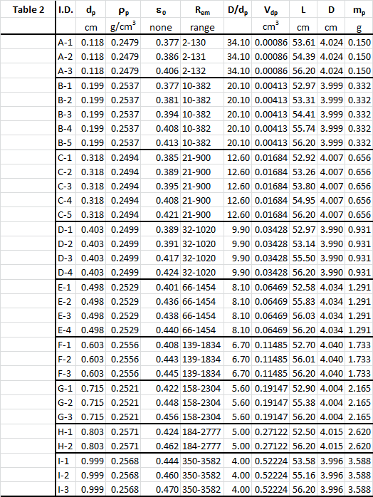

**Fig. A**

|  |  |  |  |  |  |  |  |  |  |
| --- | --- | --- | --- | --- | --- | --- | --- | --- | --- |
| |  | | --- | |  | |  |  |  |  |  |  |  |  |
|  |  |  |  |  |  |  |  |  |
|  |  |  |  |  |  |  |  |  |
|  |  |  |  |  |  |  |  |  |
|  |  |  |  |  |  |  |  |  |
|  |  |  |  |  |  |  |  |  |
|  |  |  |  |  |  |  |  |  |
|  |  |  |  |  |  |  |  |  |
|  |  |  |  |  |  |  |  |  |
|  |  |  |  |  |  |  |  |  |
|  |  |  |  |  |  |  |  |  |
|  |  |  |  |  |  |  |  |  |
|  |  |  |  |  |  |  |  |  |
|  |  |  |  |  |  |  |  |  |
|  |  |  |  |  |  |  |  |  |
|  |  |  |  |  |  |  |  |  |
|  |  |  |  |  |  |  |  |  |
|  |  |  |  |  |  |  |  |  |
|  |  |  |  |  |  |  |  |  |
|  |  |  |  |  |  |  |  |  |
|  |  |  |  |  |  |  |  |  |

|  |  |  |  |  |  |  |  |  |  |
| --- | --- | --- | --- | --- | --- | --- | --- | --- | --- |
| |  | | --- | |  | |  |  |  |  |  |  |  |  |
|  |  |  |  |  |  |  |  |  |
|  |  |  |  |  |  |  |  |  |
|  |  |  |  |  |  |  |  |  |
|  |  |  |  |  |  |  |  |  |
|  |  |  |  |  |  |  |  |  |
|  |  |  |  |  |  |  |  |  |
|  |  |  |  |  |  |  |  |  |
|  |  |  |  |  |  |  |  |  |
|  |  |  |  |  |  |  |  |  |
|  |  |  |  |  |  |  |  |  |
|  |  |  |  |  |  |  |  |  |
|  |  |  |  |  |  |  |  |  |
|  |  |  |  |  |  |  |  |  |
|  |  |  |  |  |  |  |  |  |
|  |  |  |  |  |  |  |  |  |
|  |  |  |  |  |  |  |  |  |

In our Fig. A herein, we show an elaboration of Fig. 2 and Fig. 3 in the paper. For each of the experiments we have provided in our Fig. A an elaboration of the plotted data in the paper with legends as follows;

1. **Measured** –this data represents the measured pressure drops reported in the paper.
2. **QFFM Reported**-this data represents the calculated pressure drop values generated by the pressure/ flow relationship embedded in the QFFM (as expressed in its dimensional format), based upon the values reported in the paper for the variables identified in the QFFM as being the determinants of pressure drop for the flow conduit in the experiment.
3. **QFFM Corrected**-this data represents the measured pressure drop values reported in the paper based upon corrected values generated by the pressure/ flow relationship embedded in the QFFM (as expressed in its dimensional format) for the variables identified in the QFFM as being the determinants of pressure drop for the flow conduit in the experiment.

As shown in our Fig. A, the reported values for the flow conduit experimental variables do not compute when evaluated in the dimensional format of the QFFM. . We can see that the measured pressure drops are too low for the corresponding input variables specified in Table 2 in the paper. Furthermore, we can also see from our Fig. A that the QFFM corrected variables provide a perfect fit for the measured pressure drops in both categories of fluid flow apparatus**.**

In Fig. B herein, we have provided our validation of the paper’s corrected data by a comparison of the data to Quinn’s Law. This normalized relationship is presented herein in the form of a plot of PQ versus QC, whichis the frame of reference of Quinn’s Law. This frame of reference is a transformation derived from the dimensional fluid flow relationship embedded in the QFFM. The relationship between these two unique reduced Quinn parameters is *linear*. However, we chose to present it as a *log-log plot* herein to provide emphasis at both extremes of the fluid flow regime. This plot is based upon both our own experimental data and *independent accepted classical reference data* which cover flow in both packed and empty conduits, over the entire fluid flow regime. (Note that the three distinct flow regimes of laminar, transitional and turbulent are clearly marked in the log-log plot.) As can be seen, the data reported in this paper, as corrected and as displayed in the form of a plot of PQ versus QC , lines up perfectly with Quinn’s Law

**Fig. B**

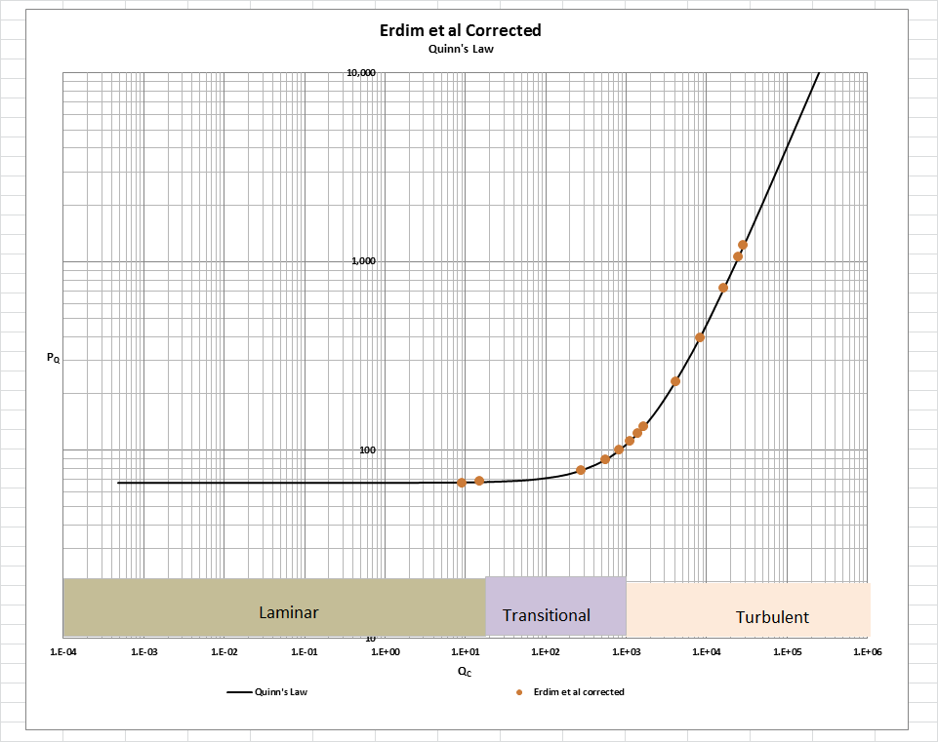

[Note: we do not herein provide the back-up for the validation of the plot of Quinn’s Law depicted in our Fig. B. For a description of the sources, both personal to TWG and from independent accepted classical references, on the basis of which the Quinn’s Law plot was validated, see the general introduction to this Universal Published Paper Review tab.

**Conclusion.**

We conclude that the results in this paper suffer from deficiencies in the experimental protocols used in the experiments. As a result, there is a mismatch between the measured variables and the measured pressure drop. This mismatch is only *apparent and quantifiable* in the context of the QFFM and, therefore, can only be corrected using this model. Accordingly, since the authors did not have access to Quinn’s Law when they wrote the paper, they *could not have* corrected the data before attempting to rationalize it by applying the model of Ergun. This inherent tendency to *modify* existing equations to correlate *unsubstantiated* empirical measurements has long since contributed to the confusion that exists in this field of study and has had a tendency to create the *false illusion* that these so-called conventional equations are of some *value* when, in reality, they are nothing more than *invalid* relationships.

Moreover, even if the authors applied the classical unmodified equations of Ergun, for instance, or their own newly-minted modified Ergun equation, they could not have generated *the* match inherent in the Laws of Nature between the calculated pressure drops of their chosen equation and their own measured pressure drops – unless, of course, they had serendipitously, or otherwise, identified the same *unique* equation as that embedded in the QFFM.

Finally, although a detailed evaluation of the experiments reported in the paper under review, including an identification and quantification of the specific variables in each fluid flow embodiment which we claim the QFFM prescribes need to be corrected, is clearly within the capability of TWG, concerns about maintaining the confidentiality of the QFFM and Quinn’s Law – which, at this time, are still proprietary - dictate that such a development is premature.