**Universal Published Paper Review**

Introduction

The Quinn Fluid Flow Model (QFFM) is a totally new and novel theory of fluid dynamics in closed conduits. The underlying intellectual property is owned by The Wrangler Group LLC (TWG). It has been developed from first principles and applies to fluid flow in both packed and empty conduits across the entire fluid flow regime including laminar, transitional and turbulent. The model has been validated by applying it to classic studies in both categories of flow embodiments and, in each case, to studies in all fluid flow regimes.

The QFFM can be expressed in two formats. The first format is a dimensional manifestation in which the measured differential pressure across the ends of a conduit is compared to the measured resultant flow rate of the fluid according to the relationships dictated by the model among the many independent and dependent variables pertaining to the physical fluid flow embodiment and pertaining to the fluid itself. The second format is a dimensionless manifestation, which we call Quinn’s Law, where all the individual respective contributions to the pressure drop/fluid flow relationship have been normalized between the model’s two entities, which we call the “Quinn reduced pressure” and the “fluid current” and which we denote with the symbols PQ and Qc, respectively.

Any given combination of the underlying variables prescribed by the QFFM will have a unique pressure drop at any given flow rate. Accordingly, the QFFM is capable of distinguishing between *valid* and *invalid* data. In particular, the QFFM can identify a mismatch between a practitioner’s statement of the values he/she claims to have measured or calculated for the QFFM variables and the practitioner’s measured flow rate and pressure drop. We consider any mismatch to be an *invalid* empirical result. It follows that for every *invalid* empirical result there is but one *valid* corrected result.

Before one can apply Quinn’s Law to any given empirical result that result has to be validated using the dimensional manifestation of the QFFM. This, in turn, is because one cannot normalize properly for all the individual respective contributions unless all the variables are correctly identified and their values are commensurate with the measured pressure drops and fluid flow rates. In general, we can state that since most of the underlying variables pertaining to a fluid flow embodiment are relatively easy to measure, the correction usually pertains to the more difficult-to-measure variables. In the case of a packed conduit, the problematical measurements include particle sphericity, average particle diameter and conduit external porosity, In the case of an empty conduit, the weak link in terms of measurability is the conduit’s inner wall roughness.

QFFM is a unique and powerful new tool in the arsenal of the fluid flow practitioner. In particular, when experiments are conducted in the transitional and/or turbulent regimes, the conventional methodology does not provide any reliable way to verify the accuracy of the results across a broad spectrum of Reynolds numbers. Thus, it is in these regions of the fluid flow regime that the QFFM will be shown to be most useful. In fact, it is a direct consequence from the statements contained herein that one needs only to measure pressure drop and fluid flow rate to evaluate the quality of one’s experimental technique. This new development in fluid dynamics means that those of us who have spent our entire lives doing fluid flow measurements can now enjoy the same benefits as our counterparts within the field of electricity and magnetism.

Paper Summary

We review here a published article in ***Experimental Thermal and Fluid Science 57 (2014) 425-433*,** entitled “***Experimental flow in various porous media and reconciliation of Forchheimer and Ergun relations”,*** by Dukhan **et al**. For easy reference to the reader, we print here in its entirety the abstract in the paper.

**Paper Abstract**

*Flow characteristics and pressure drop in traditional porous media, e.g., packed beds of spheres, and in modern man-made fibrous media, e.g., metal foam, are critical in many naturally-occurring and engineered applications. Pressure drop parameters such as permeability and form/inertial drag coefficients reported in the literature are very divergent for both classes of porous media. The choice of an approximated characteristic length; and the selection of a way for correlating pressure drop data have also varied among researchers. In the current study a large set of experimental data for pressure drop of water flow in three different porous media was collected. The porous media were packed spheres of 1 mm, packed spheres of 3 mm and aluminum foam having 20 pores per inch. The porosity of both sets of packed spheres was practically the same at about 35%, while the porosity of the foam was 87.6%. The internal structure of the two classes (packed spheres and foam) of porous media investigated here are markedly different. The range of flow velocity covered Darcy, Forchheimer and turbulent flow regimes. It is shown that the same porous medium exhibited different values of permeability in different flow regimes. The widely-used equations of Ergun and Forchheimer for the post-Darcy regimes were revisited. An apparent difference between the two famous equations was presented and explained. The two equations were reconciled using the hydraulic radius theory, and the fact that the same porous medium exhibits different values of its permeability in different flow regimes. The multipliers of the viscous term and the inertial/form drag term in the post-Darcy regimes were shown to be connected. The square root of the permeability determined in the Darcy regime is shown to be appropriate length scale for defining and correlating the friction factor and the Reynolds number.*

**Data Analysis**

TWG has performed an extensive evaluation of the above referenced published article utilizing the QFFM. We commence our evaluation of the paper with an in-depth analysis of the reported data.

In our Fig. A herein, we show an elaboration of Fig. 2 in the paper for the experimental data reported for the 1 mm and 3mm glass spheres as well as the metal foam with the following plotted legends;

1. **Measured** –this data represents the measured pressure drops reported in the paper.
2. **QFFM Reported**-this data represents the calculated pressure drop values generated by the pressure/ flow relationship embedded in the QFFM (as expressed in its dimensional format), based upon the values reported in the paper for the variables identified in the QFFM as being the determinants of pressure drop for the flow conduit in the experiment.
3. **QFFM Corrected**-this data represents the measured pressure drop values reported in the paper based upon corrected values generated by the pressure/ flow relationship embedded in the QFFM (as expressed in its dimensional format) for the variables identified in the QFFM as being the determinants of pressure drop for the flow conduit in the experiment.

As shown in our Fig. A, the reported values for the flow conduit experimental variables do not compute when evaluated in the dimensional format of the QFFM. We can see that, in the case of the conduits packed with the 1mm and 3 mm glass beads, the measured pressure drops are too low for the corresponding input variables specified in the paper, whereas, in the case of the metal foam, they are too high. Furthermore, we can also see from our Fig. A that the QFFM corrected variables provide a perfect fit for the measured pressure drops in both categories of fluid flow apparatus.

**Fig. A-1**

**Fig. A-2**

**Fig. A-3**

In Fig. B herein, we have provided our validation of the paper’s corrected data by a comparison of the data to Quinn’s Law. This normalized relationship is presented herein in the form of a plot of PQ versus QC, whichis the frame of reference of Quinn’s Law. This frame of reference is a transformation derived from the dimensional fluid flow relationship embedded in the QFFM. The relationship between these two unique reduced Quinn parameters is *linear*. However, we chose to present it as a *log-log plot* herein to provide emphasis at both extremes of the fluid flow regime. This plot is based upon both our own experimental data and *independent accepted classical reference data* which cover flow in both packed and empty conduits, over the entire fluid flow regime. (Note that the three distinct flow regimes of laminar, transitional and turbulent are clearly marked in the log-log plot.) As can be seen, the data reported in this paper, as corrected and as displayed in the form of a plot of PQ versus QC , lines up perfectly with Quinn’s Law

**Fig. B**

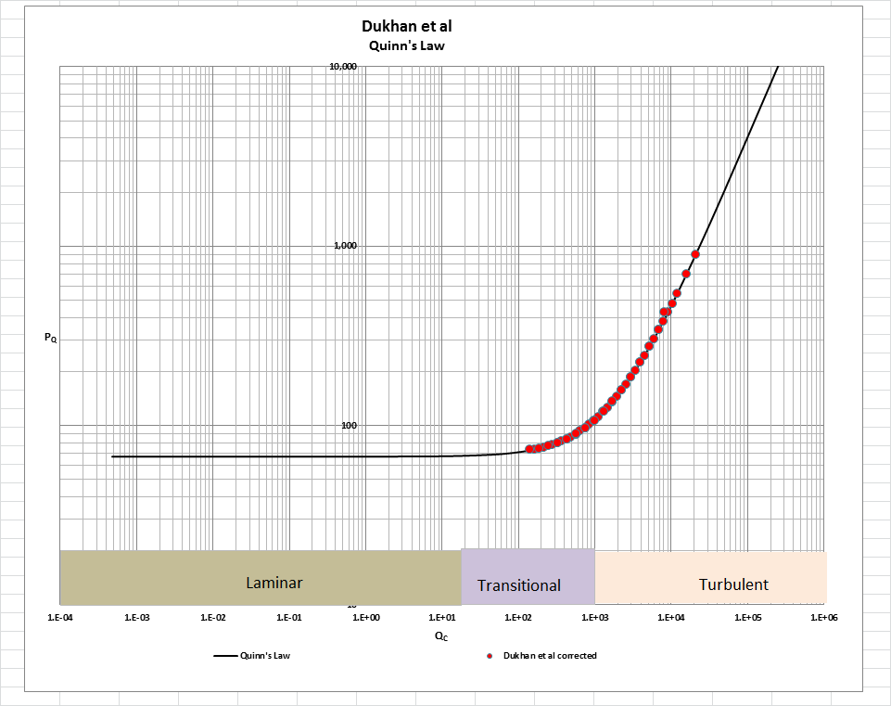

[Note: we do not herein provide the back-up for the validation of the plot of Quinn’s Law depicted in our Fig. B. For a description of the sources, both personal to TWG and from independent accepted classical references, on the basis of which the Quinn’s Law plot was validated, see the general introduction to this Universal Published Paper Review tab.

**Conclusion.**

We conclude that the results in this paper suffer from deficiencies in the experimental protocols used in the experiments. As a result, there is a mismatch between the measured variables and the measured pressure drop. This mismatch is only *apparent and quantifiable* in the context of the QFFM and, therefore, can only be corrected using this model. Accordingly, since the authors did not have access to Quinn’s Law when they wrote the paper, they *could not have* corrected the data before attempting to rationalize it by applying the models of Ergun and Forchheimer. This inherent tendency to *modify* existing equations to correlate *unsubstantiated* empirical measurements has long since contributed to the confusion that exists in this field of study and has had a tendency to create the *false illusion* that these so-called conventional equations are of some *value* when, in reality, they are nothing more than *invalid* relationships.

Moreover, even if the authors applied the classical unmodified equations of Ergun or Forchheimer, for instance, or their own newly-minted modified Ergun/Forchheimer equation, they could not have generated *the* match inherent in the Laws of Nature between the calculated pressure drops of their chosen equation and their own measured pressure drops – unless, of course, they had serendipitously, or otherwise, identified the same *unique* equation as that embedded in the QFFM.

Finally, although a detailed evaluation of the experiments reported in the paper under review, including an identification and quantification of the specific variables in each fluid flow embodiment which we claim the QFFM prescribes need to be corrected, is clearly within the capability of TWG, concerns about maintaining the confidentiality of the QFFM and Quinn’s Law – which, at this time, are still proprietary - dictate that such a development is premature.