**Universal Published Paper Review**

Introduction

The Quinn Fluid Flow Model (QFFM) is a totally new and novel theory of fluid dynamics in closed conduits. The underlying intellectual property is owned by The Wrangler Group LLC (TWG). It has been developed from first principles and applies to fluid flow in both packed and empty conduits across the entire fluid flow regime including laminar, transitional and turbulent. The model has been validated by applying it to classic studies in both categories of flow embodiments and, in each case, to studies in all fluid flow regimes.

The QFFM can be expressed in two formats. The first format is a dimensional manifestation in which the measured differential pressure across the ends of a conduit is compared to the measured resultant flow rate of the fluid according to the relationships dictated by the model among the many independent and dependent variables pertaining to the physical fluid flow embodiment and pertaining to the fluid itself. The second format is a dimensionless manifestation, which we call Quinn’s Law, where all the individual respective contributions to the pressure drop/fluid flow relationship have been normalized between the model’s two entities, which we call the “Quinn reduced pressure” and the “fluid current” and which we denote with the symbols PQ and Qc, respectively.

Any given combination of the underlying variables prescribed by the QFFM will have a unique pressure drop at any given flow rate. Accordingly, the QFFM is capable of distinguishing between *valid* and *invalid* data. In particular, the QFFM can identify a mismatch between a practitioner’s statement of the values he/she claims to have measured or calculated for the QFFM variables and the practitioner’s measured flow rate and pressure drop. We consider any mismatch to be an *invalid* empirical result. It follows that for every *invalid* empirical result there is but one *valid* corrected result.

Before one can apply Quinn’s Law to any given empirical result that result has to be validated using the dimensional manifestation of the QFFM. This, in turn, is because one cannot normalize properly for all the individual respective contributions unless all the variables are correctly identified and their values are commensurate with the measured pressure drops and fluid flow rates. In general, we can state that since most of the underlying variables pertaining to a fluid flow embodiment are relatively easy to measure, the correction usually pertains to the more difficult-to-measure variables. In the case of a packed conduit, the problematical measurements include particle sphericity, average particle diameter and conduit external porosity, In the case of an empty conduit, the weak link in terms of measurability is the conduit’s inner wall roughness.

QFFM is a unique and powerful new tool in the arsenal of the fluid flow practitioner. In particular, when experiments are conducted in the transitional and/or turbulent regimes, the conventional methodology does not provide any reliable way to verify the accuracy of the results across a broad spectrum of Reynolds numbers. Thus, it is in these regions of the fluid flow regime that the QFFM will be shown to be most useful. In fact, it is a direct consequence from the statements contained herein that one needs only to measure pressure drop and fluid flow rate to evaluate the quality of one’s experimental technique. This new development in fluid dynamics means that those of us who have spent our entire lives doing fluid flow measurements can now enjoy the same benefits as our counterparts within the field of electricity and magnetism.

Paper Summary

We review here a published article in **22nd International Congress of Mechanical Engineering (COBEM 2013) November 3-7, 2013, Ribeirão Preto, SP, Brazil** entitled **EXPERIMENTAL STUDY ON THE APPLICABILITY OF ERGUN EQUATION IN BEDS WITH HOLLOW SPHERES** by **Cruz et al.** For easy reference to the reader, we print here in its entirety the abstract in the paper.

**Paper Abstract**

Many studies are conducted about the dynamics of fluids in porous media, which generates a number of factors and problems that are solved. In particular the phenomenon of pressure drop in flows on fixed bed, although fairly well in the form Ergun equation, still has certain applicability with regard to the shape of materials and characteristics of surface to be used in the packaging of the beds. The purpose of this paper is to realize a study of frictional pressure drop experimental results from fixed bed composed of hollow sphere, applying the Ergun equation with appropriate adaptations to the case of hollow sphere. The study will also raise properties for determining the frictional pressure drop as shape factor, porosity and tortuosity of the bed, as well as growth for various lengths bed. The main objective was to validate the experimental procedure and apparatus through data that were obtained according to the mentioned equation.

**Data Analysis**

TWG has performed an extensive evaluation of the above referenced published article utilizing the QFFM. We commence our evaluation of the paper with an in-depth analysis of the reported data.

We begin by mentioning that because of language issues this paper is difficult to understand. In addition, the graphs in the paper have mislabeled legends. Nevertheless, we believe that we have been able to properly understand all the relevant data. In presenting our analysis herein we consider the measured data for the three packed conduits containing spherical particles of diameters 1.387, 1.887 and 2.387 cm, whose measured data are presented in Fig 7, 6 and 5, respectively. Our analysis for the three packed columns is presented herein in conjunction with our Figs A-1 through A-3. Our analysis is based upon the reported values for particle diameter (dp) and packed conduit external porosity (0). For each of the three columns we present a comparison of the measured data and the calculated values using (a) our Q modified Ergun type equation and (b) the classic Ergun equation. In each case we show two plots; one is an elaboration of the plot in the paper for a specific column and the other is a plot of the friction factor (f) derived from each of the two distinct equations plotted against the modified Reynolds number (Rem) for that same column.

The QFFM recognizes the element of continuity dictated by the Laws of Nature and, accordingly, identifies values for the *unique* combination of dp and 0 underlying the measured values of pressure gradient and flow rate reported in the experiment. If the measurement technique used by the authors is both accurate and precise, the reported values for these two variables will coincide with those identified by the QFFM. If not, there will be a discrepancy between the reported and calculated values generated by the QFFM. In addition, we stipulate that our plot representing the measured data is taken from the data plotted in each of the Fig 5, 6 and 7 in the paper which we elaborate by the use of a second order polynomial relationship between the measured variable of superficial linear velocity (s) and pressure gradient (P/L).

In our Fig A-1 herein, we present our analysis for the column containing the smallest particles, i.e. dp = 1.387 cm. The QFFM returns a corresponding value for 0 of 0.444, *which is in conflict with the reported value of 0.455* for this variable reported in the paper. We identify the value for 0 = 0.455 from the curve in Fig 7 representing the classic Ergun equation calculated values. As shown in A-1, the Q modified Ergun type equation correlates the data perfectly and renders values of 268 and 1.82 for the Ergun type constants k1 and k2, respectively. It is also obvious from the plots that the classic Ergun equation, which treats these two variables as *independent* variables, does not correlate the measured data when the reported values for particle size of 1.387cm and external porosity 0.445 are used as inputs into the classic Ergun equation.

In our Fig A-2 herein, we present our analysis for the column containing the next larger particles, i.e. dp = 1.887 cm. The QFFM returns a corresponding value for 0 of 0.45, *which is in conflict with the reported value of 0.434* for this variable reported in the paper. We identify the value for 0 = 0.434from the curve in Fig 6 representing the classic Ergun equation calculated values. As shown in A-2, the Q modified Ergun type equation correlates the data perfectly and renders values of 268 and 1.75 for the Ergun type constants k1 and k2, respectively. It is also obvious from the plots that the classic Ergun equation, which treats these two variables as *independent* variables, does not correlate the measured data *precisely* when the reported values for particle size of 1.887cm and external porosity 0.434 are used as inputs into the classic Ergun equation.

Finally, in our Fig A-3 herein, we present our analysis for the column containing the largest particles, i.e. dp = 2.387 cm. The QFFM returns a corresponding value for 0 of 0.444, *which is in conflict with the reported value of 0.426* for this variable reported in the paper. We identify the value for 0 = 0.426from the curve in Fig 5 representing the classic Ergun equation calculated values. As shown in A-3, the Q modified Ergun type equation correlates the data perfectly and renders values of 268 and 1.82 for the Ergun type constants k1 and k2, respectively. It is also obvious from the plots that the classic Ergun equation, which treats these two variables as *independent* variables, does not correlate the measured data *precisely* when the reported values for particle size of 2.387cm and external porosity 0.426 are used as inputs into the classic Ergun equation.

In our Fig. A-4 we show a table which contains a comparison of the values of the important variables contained in our analysis. Please note that each of the various possibilities considered in our analysis generated a slightly different range of modified Reynolds number (Rem) for the same measured flow rates.

Fig A-1

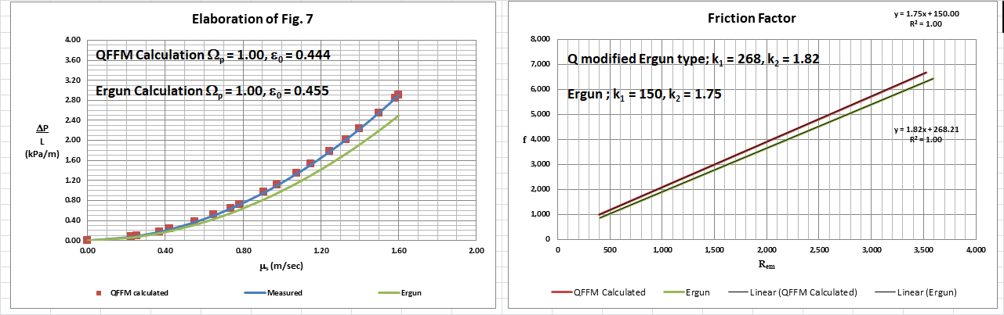

Fig. A-2

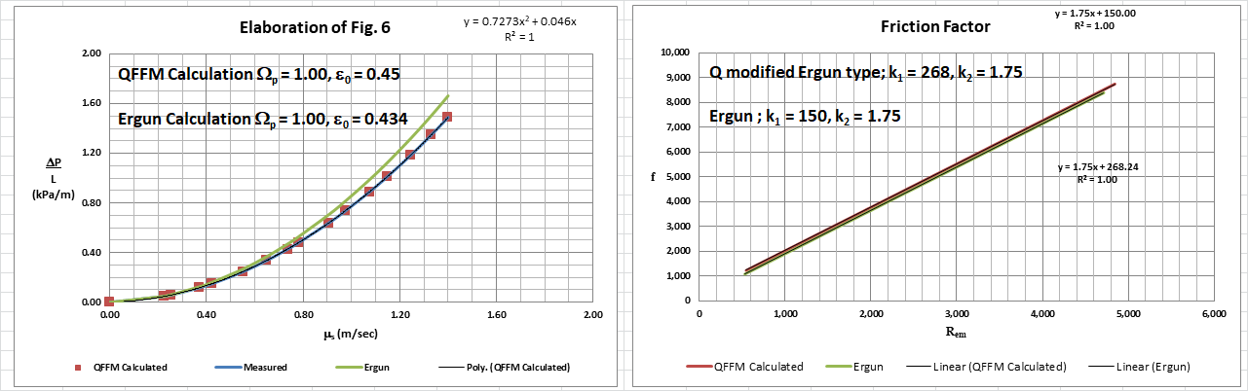

Fig. A-3

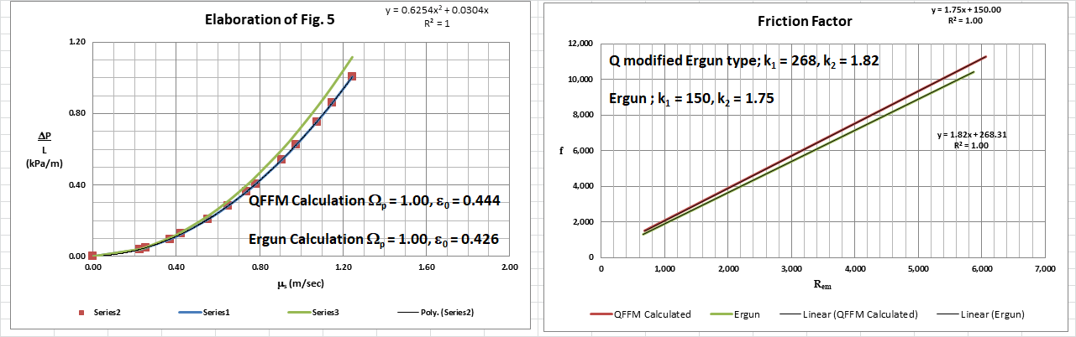

Fig. A-4

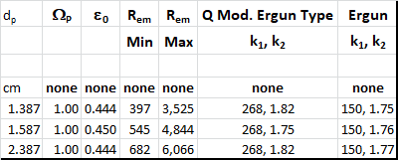

In Fig. B herein, we have provided our validation of the papers corrected data by a comparison of the data to Quinn’s Law. This normalized relationship is presented herein in the form of a plot of PQ versus QC, whichis the frame of reference of Quinn’s Law. This frame of reference is a transformation derived from the dimensional fluid flow relationship embedded in the QFFM. The relationship between these two unique reduced Quinn parameters is *linear*. However, we chose to present it as a *log-log plot* herein to provide emphasis at both extremes of the fluid flow regime. This plot is based upon both our own experimental data and *independent accepted classical reference data* which cover flow in both packed and empty conduits, over the entire fluid flow regime. (Note that the three distinct flow regimes of laminar, transitional and turbulent are clearly marked in the log-log plot.) As can be seen, the data reported in this paper, as corrected and as displayed in the form of a plot of PQ versus QC , lines up perfectly with Quinn’s Law.

**Fig. B**

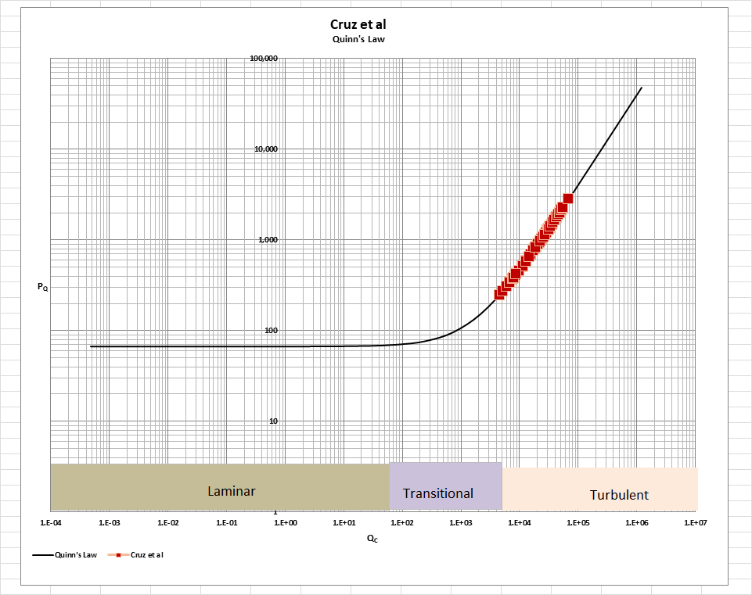

[Note: we do not herein provide the back-up for the validation of the plot of Quinn’s Law depicted in our Fig. B. For a description of the sources, both personal to TWG and from independent accepted classical references, on the basis of which the Quinn’s Law plot was validated, see the general introduction to this Universal Published Paper Review tab.

**Conclusion.**

We conclude that the measurement technique used by the authors was very effective if not completely accurate and precise as defined in the context of the QFFM. Although the

classic Ergun equation does not recognize the concept of continuity, nevertheless, the particular combination of variables in the experiments here show the Ergun equation in its best light, i.e. it correlates data best when the external porosity in the packed conduit is precisely 0.45, which, accordingly, represents the sweet spot of the equation. In addition, the particles here were also perfect spheres and the authors went to great lengths to measure the particle diameters accurately. As shown in our analysis, the classic Ergun equation did a reasonable job of predicting the pressure gradients, but lacks the accuracy and precision of the QFFM even under experimental conditions most favorable to the classic Ergun equation.

Accordingly, there is a slight mismatch between the apparent measured values for spherical particle diameter equivalent, the reported values for column external porosity and the measured pressure drop and flow rates. This mismatch is only *apparent and quantifiable* in the context of the QFFM and, therefore, can only be corrected using this model. Accordingly, since the authors did not have access to Quinn’s Law when they wrote the paper, they *could not have* corrected the data before attempting to present it in the published paper. The inherent tendency to *modify* existing equations to correlate *unsubstantiated* empirical measurements has long since contributed to the confusion that exists in this field of study and has had a tendency to create the *false illusion* that these so-called conventional equations are of some *value* when, in reality, they are nothing more than *invalid* relationships.

Finally, although a detailed evaluation of the experiments reported in the paper under review, including an identification and quantification of the specific variables in each fluid flow embodiment which we claim the QFFM prescribes need to be corrected, is clearly within the capability of TWG, concerns about maintaining the confidentiality of the QFFM and Quinn’s Law – which, at this time, are still proprietary - dictate that such a development is premature.