**Universal Published Paper Review**

Introduction

The Quinn Fluid Flow Model (QFFM) is a totally new and novel theory of fluid dynamics in closed conduits. The underlying intellectual property is owned by The Wrangler Group LLC (TWG). It has been developed from first principles and applies to fluid flow in both packed and empty conduits across the entire fluid flow regime including laminar, transitional and turbulent. The model has been validated by applying it to classic studies in both categories of flow embodiments and, in each case, to studies in all fluid flow regimes.

The QFFM can be expressed in two formats. The first format is a dimensional manifestation in which the measured differential pressure across the ends of a conduit is compared to the measured resultant flow rate of the fluid according to the relationships dictated by the model among the many independent and dependent variables pertaining to the physical fluid flow embodiment and pertaining to the fluid itself. The second format is a dimensionless manifestation, which we call Quinn’s Law, where all the individual respective contributions to the pressure drop/fluid flow relationship have been normalized between the model’s two entities, which we call the “Quinn reduced pressure” and the “fluid current” and which we denote with the symbols PQ and Qc, respectively.

Any given combination of the underlying variables prescribed by the QFFM will have a unique pressure drop at any given flow rate. Accordingly, the QFFM is capable of distinguishing between *valid* and *invalid* data. In particular, the QFFM can identify a mismatch between a practitioner’s statement of the values he/she claims to have measured or calculated for the QFFM variables and the practitioner’s measured flow rate and pressure drop. We consider any mismatch to be an *invalid* empirical result. It follows that for every *invalid* empirical result there is but one *valid* corrected result.

Before one can apply Quinn’s Law to any given empirical result that result has to be validated using the dimensional manifestation of the QFFM. This, in turn, is because one cannot normalize properly for all the individual respective contributions unless all the variables are correctly identified and their values are commensurate with the measured pressure drops and fluid flow rates. In general, we can state that since most of the underlying variables pertaining to a fluid flow embodiment are relatively easy to measure, the correction usually pertains to the more difficult-to-measure variables. In the case of a packed conduit, the problematical measurements include particle sphericity, average particle diameter and conduit external porosity, In the case of an empty conduit, the weak link in terms of measurability is the conduit’s inner wall roughness.

QFFM is a unique and powerful new tool in the arsenal of the fluid flow practitioner. In particular, when experiments are conducted in the transitional and/or turbulent regimes, the conventional methodology does not provide any reliable way to verify the accuracy of the results across a broad spectrum of Reynolds numbers. Thus, it is in these regions of the fluid flow regime that the QFFM will be shown to be most useful. In fact, it is a direct consequence from the statements contained herein that one needs only to measure pressure drop and fluid flow rate to evaluate the quality of one’s experimental technique. This new development in fluid dynamics means that those of us who have spent our entire lives doing fluid flow measurements can now enjoy the same benefits as our counterparts within the field of electricity and magnetism.

Paper Summary

We review here a published article in the **Journal of Chromatography A, 1178 (2008) 108,** entitled **Detailed characterization of the flow resistance of commercial sub-2m reversed-phase columns**, by **Cabooter et al**. For easy reference to the reader, we print here in its entirety the abstract in the paper.

**Paper Abstract**

The pressure-drop characteristics of six sub-2 m columns of three different manufacturers but with the same surface chemistry (C18) have been studied using the recently introduced total pore blocking method for the determination of the external porosity and by using scanning electron microscopy pictures to measure the actual size of the particles. Having used the Sauter-mean particle size to correctly account for the particle size spread, and having corrected for the influence of the intra-particle porosity, it was found that all columns yielded Kozeny–Carman constant (*f*KC) values close to 180, in agreement with the theory. This agreement could subsequently be used to quantify how the different system parameters

Such as mean particle size, packing density and intra-particle porosity (all tending to vary significantly from manufacturer to manufacturer) each contributes to the observed total bed permeability. Small (upward) deviations from the *f*KC = 180-value could be correlated to a larger width of the particle size distribution, and more notably to the existence of a high size ratio of the largest to the smallest particles present in the particle batches.

**Data Analysis**

TWG has performed an extensive evaluation of the above referenced published article utilizing the QFFM. We commence our evaluation of the paper with an in-depth analysis of the reported data.

As shown in our Fig. A-1, we have created a graphical representation of the measured data presented in Table 2 of the paper. On our graph we show a plot of column pressure versus flow rate. Although the paper is all about particle porosity, p, and column pressure drops, P, the authors, curiously, reported neither in the paper, but instead reported the column permeability based upon the use of interstitial fluid velocity, Ki. We have converted this reported data into our format on the plot such that we can highlight the author’s methodology of reporting their measurements and hence explore their apparent preordained conclusion concerning the value of the Kozeny/Carman constant, which is based on superficial velocity not interstitial velocity, as well as the values of the various column permeabilities corresponding to the actual column pressure drops measured. As can be seen in the plot, 5 of the six columns have measured pressure drop data that is clustered together. The remaining column, number 4, stands by itself on the graph because this column had a diameter of 0.46 cm and at the flow rates presented in the graph this represents a significantly lower fluid velocity and thus a lower pressure drop than the other 5 columns whose column diameter was 0.21 cm.

Fig. A-2 herein shows a comparison between the reported data and our corrected values for the packed column underlying variables as well as the permeabilities, all based upon the application of the QFFM. In particular, we point out the discrepancies in the reported values of external porosities, 0, especially those of the Acquity columns, as well as the other glaring omissions by the authors of relevant data highlighted therein, i.e. column skeletal porosity, s, and total conduit porosity, conduit. In addition, it can be seen that our QFFM corrected values for the column permeabilities Ki and K t, and column resistant parameters, i and t, are only slightly different to those presented by the authors.

In our Fig A-3 herein, for validation purposes, we show another plot of our corrected data on the same axes as in our Fig. A-1. As can be seen in the plot, our corrections for the measurement discrepancies in the calculated permeabilities by the paper authors generate precisely the same values for flow rate and corresponding pressure drop as does the values reported in the paper.

**Fig. A-1**

**Fig. A-2**

**Data Comparison; Reported v QFFM Corrected**

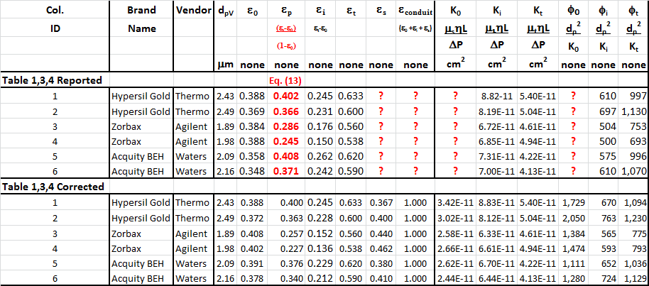

**Fig. A-3**

In Fig. B herein, we have provided our validation of the papers corrected data by a comparison of the data to Quinn’s Law. This normalized relationship is presented herein in the form of a plot of PQ versus QC, whichis the frame of reference of Quinn’s Law. This frame of reference is a transformation derived from the dimensional fluid flow relationship embedded in the QFFM. The relationship between these two unique reduced Quinn parameters is *linear*. However, we chose to present it as a *log-log plot* herein to provide emphasis at both extremes of the fluid flow regime. This plot is based upon both our own experimental data and *independent accepted classical reference data* which cover flow in both packed and empty conduits, over the entire fluid flow regime. (Note that the three distinct flow regimes of laminar, transitional and turbulent are clearly marked in the log-log plot.) As can be seen, the data reported in this paper, as corrected and as displayed in the form of a plot of PQ versus QC , lines up perfectly with Quinn’s Law

**Fig. B**

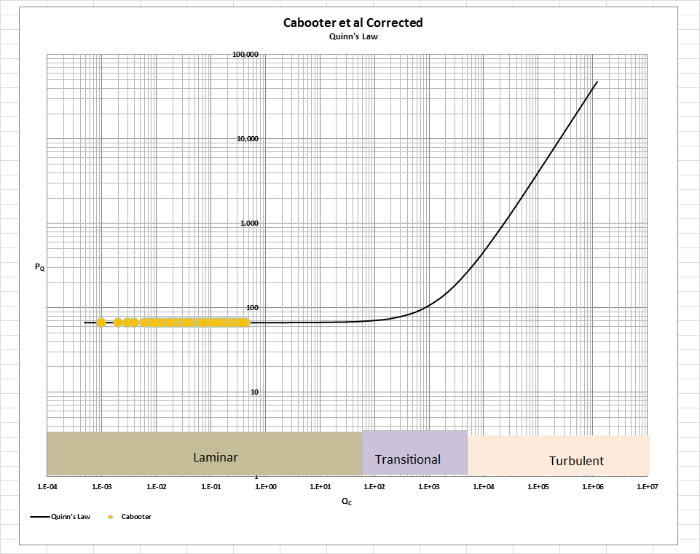

[Note: we do not herein provide the back-up for the validation of the plot of Quinn’s Law depicted in our Fig. B. For a description of the sources, both personal to TWG and from independent accepted classical references, on the basis of which the Quinn’s Law plot was validated, see the general introduction to this Universal Published Paper Review tab.

**Conclusion.**

We conclude that the results in this paper suffer from deficiencies in the experimental protocols and methodologies used to capture the measured data from the experiments. Surprisingly, we find the authors discussion of their rationale underlying their apparently preordained conclusion that their measured pressure drop results support a value of 180 for the Kozeny/Carman constant, disingenuous at best. Moreover, their assertion that the value of 180 for the constant is a “theoretical” value, is plain wrong. Nowhere in the entire literature of fluid flow in closed conduits does anyone describe a theory which dictates the value of 180 as a theoretically derived value for the Kozeny/Carman constant.

We are even more surprised at the author’s naiveté concerning the fictitiously low values of external porosity quoted by the manufacturer of the acquity columns and, in particular, their suggestion that this could be a result of “radial compression” is simply ludicrous since these are stainless steel columns and not part of the family of hydraulically radially compressed plastic cartridges offered by Waters. It has long been the practice of vendors of chromatographic columns to play hide-and-go-seek with particle size values and measurements for reasons related to product marketing. In the case of these so-called sub 2 micron particles, it is clear that if the measured values for particle size, dp#, dpV or dpsa are used, none of which fall below the value of 2 micron, the “superior” column efficiency claims of the manufacturer ring hollow. In the end, therefore, it is the continuity aspect of the Laws of Nature that governs in this particular application scenario. Consequently, one is prohibited by continuity to “have one’s cake and eat it” by claiming , on the one hand, that the particles are below 2 micron (which they are not) and , simultaneously, on the other hand, that the external porosity is also below what is commensurate with what the measured pressure drops dictate, by manipulating in the author’s calculations of column permeability, the constant in the Kozeny/Carman equation by using a different value for the constant for each individual column to make it “appear” that the correlation is legitimate beteen measured and calculated, while at the same time, proclaiming with forked tongue that “ all columns yielded Kozeny–Carman constant (*f*KC) values close to 180, in agreement with the theory”.

Astonishingly, it is blatantly obvious from equation (13) in the paper, for instance, that the authors put the rabbit in the hat by back-calculating the value for particle porosity from their column measurements of total and external porosity. Particle porosity is an independent column variable and is not a function of any measured column parameter. Moreover, the authors compound this glaring error even further in the text by confusing their misleadingly labelled parameter, int, which represents particle porosity with another term representing column internal porosity which we give the symbol i, as follows; “When comparing the internal porosity of different columns, it is immediately clear that the Zorbax columns display a much lower internal porosity than the other columns…..” Accordingly, they intertwine a column porosity term with a particle porosity term which conveniently supports their ulterior motive of “cooking the books” with regard to the value of the constant in the Kozeny/Carman equation.

Importantly, as shown in our data comparison herein, the authors completely ignore the concept of continuity in presenting the partial porosities of all the columns. Clearly, it is this lack of scientific fundamentals that supports their preordained proclamation.

As a result, there is a mismatch between the apparent measured variables, the reported column permeabilities and the measured pressure drop. This mismatch is only *apparent and quantifiable* in the context of the QFFM and, therefore, can only be corrected using this model. Accordingly, since the authors did not have access to Quinn’s Law when they wrote the paper, they *could not have* corrected the data before attempting to present it in the published paper. This inherent tendency to *modify* existing equations to correlate *unsubstantiated* empirical measurements has long since contributed to the confusion that exists in this field of study and has had a tendency to create the *false illusion* that these so-called conventional equations are of some *value* when, in reality, they are nothing more than *invalid* relationships

Finally, although a detailed evaluation of the experiments reported in the paper under review, including an identification and quantification of the specific variables in each fluid flow embodiment which we claim the QFFM prescribes need to be corrected, is clearly within the capability of TWG, concerns about maintaining the confidentiality of the QFFM and Quinn’s Law – which, at this time, are still proprietary - dictate that such a development is premature.